**YOUNG WORKERS STRATEGY 2021-2023**

## BACKGROUND AND RATIONALE

WorkSafe ACT’s functions are set out in the *Work Health and Safety Act 2011* (WHS Act*)*, and include:

* promoting an understanding of, and acceptance and compliance with, the WHS Act or another territory law relating to work health and safety (WHS); and
* research and development of educational and other programs for the purpose of promoting WHS.

Section 19 of the WHS Act provides that a person conducting a business or undertaking (PCBU) must ensure, so far as is reasonably practicable, the health and safety of workers.

**The WHS Act defines health as both physical and psychological health**

WorkSafe ACT’s *Young Workers Strategy 2021-2023* (the Strategy) has been developed in alignment with WorkSafe ACT’s planning framework and encompasses the policies within:

* [Strategic Plan 2020-2024](https://www.legislation.act.gov.au/ni/2020-680/)
* Statement of Operational Intent, and
* [Compliance and Enforcement Policy 2020-2024](https://www.legislation.act.gov.au/ni/2020-681/).

The Strategy is based on WorkSafe ACT’s data and business intelligence and the four high-level strategies that underpin its activities, as set out in the Strategic Plan 2020-2024:

Ensure fair and firm enforcement against non-compliance.
Minimise physical and psychological harm and improve WHS practice and culture. 
Engage with stakeholders to better understand and respond to current and emerging WHS issues.
Create an exemplary regulator.

Young workers are workers aged up to 25 years, including apprentices, school-based apprentices, and trainees. This also includes all forms of employment, including but not limited to casual, freelance or gig, labour hire, temporary, unpaid internships, work experience and work placements, full-time and part-time work.

Young workers are one of the most vulnerable cohorts in workplaces. Research suggests that young workers may be at a higher risk of injury due to factors such as[1]:

* inexperience – young workers have limited experience with safety risks; injury risk is the highest in the first few months of employment[2]
* inadequate training and supervision – Master Builders ACT has stated “it is a known fact that apprentices and trainees require a higher level of supervision than other workers.”[3]
* being unaware of work health and safety rights and responsibilities.

This cohort’s general lack of experience in the workplace and with workplace hazards, risks and exposure results in an inherent power imbalance that leaves younger workers facing significant barriers to speaking up and challenging unsafe working practices. This is further compounded when young workers are unaware of their rights and responsibilities when it comes to WHS, industrial relations and workers’ compensation.

Young workers make up **39**% of the employed population in the ACT[4], yet last year accounted for nearly **half** of all workers’ compensation claims. The chart below shows the proportion of claims in each age group compared to the proportion employed. Ideally, the two series would be the same. However, empirically, we can see that is not the case.

For young workers, **94%** of workers’ compensation claims are for injuries of a physical nature. The top industry with these claims is Construction, with **27**% of all claims. The jobs with the greatest number of claims are miscellaneous labourers, carpenters and joiners, and electricians.

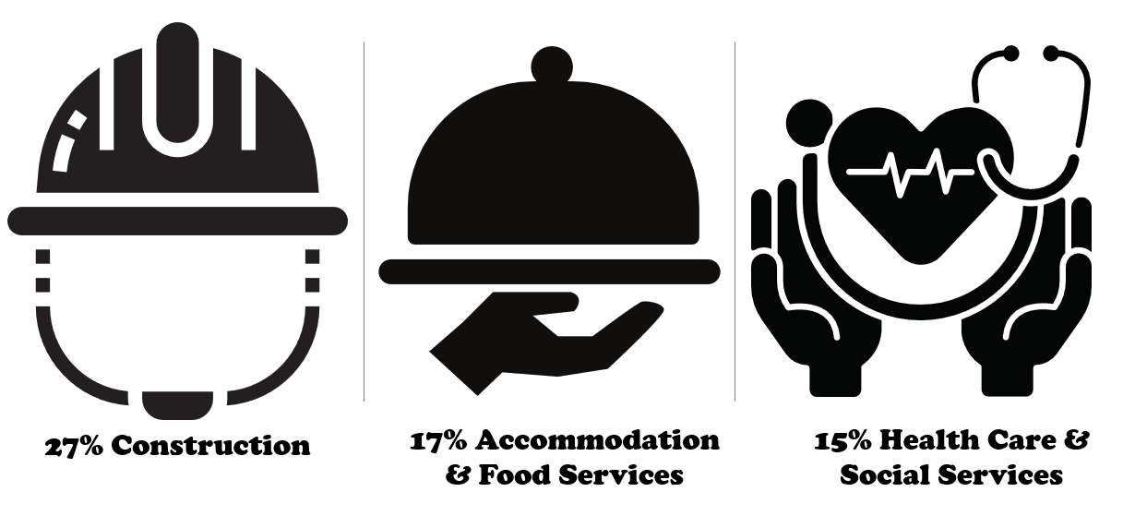

The top mechanisms for injury for young workers in the ACT are:

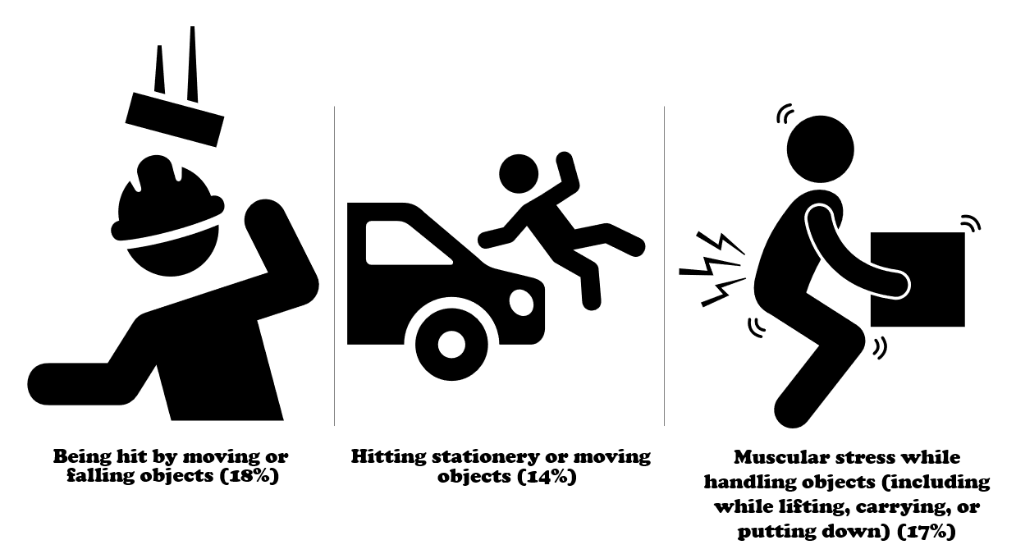

The *Respect@Work: National Inquiry into Sexual Harassment in Australia Workplaces 2020**[5]* report stated that workers who may be more likely to experience sexual harassment in the workplace included young workers aged less than 30 years. The *2018 National Survey on Sexual Harassment in Australian Workplaces*[6]reported that young people aged 18 to 29 were the age group most likely to experience technology-based workplace harassment.

In series of focus groups with construction industry apprentices, workers spoke about:

* long hours and being expected to work overtime
* travelling long distances to work
* working in extreme heat, and
* low pay.

However, the biggest issue noted was poor treatment by supervisors and quality of supervision*[7]*. All of these hazards can lead to both physical and psychosocial injuries in young workers.

*Young Australian males working in the construction industry are twice as likely to take their own lives than other young Australian males. […] Previous research has indicated a bullying culture within this industry, directed particularly toward apprentices and those new to the industry.  The results revealed that a substantial proportion of construction industry apprentices experience workplace bullying*

Frontiers in Psychiatry, May 2021, *Factors Associated with Workplace Bullying and the Mental Health of Construction Industry Apprentices: A Mixed Methods Study*

Every young worker in the Territory has the same right to be safe at work, both physically and psychologically, as all other workers. In the creation of this Strategy, WorkSafe ACT engaged with young workers via ‘Own Voice’ sessions and forums. The WHS challenges we heard about from this cohort mirrored recent research, including:

* inadequate training, including induction and ongoing training
* limited understanding of WHS legislative obligations of employers
* anecdotal evidence of the poor understanding by PCBUs of psychosocial hazards and the risks of incidents such as work-related violence and sexual harassment when these hazards are not effectively managed
* mental health issues, and
* a reluctance to voice concerns or report issues due to factors including:
* not knowing where to report, and
* fear of losing a job or hours being cut.

What we heard from young workers:
'feeling disposable', no training', 'poor co-worker support'. 

## PURPOSE

This Strategy is the overarching document that captures WorkSafe ACT’s approach to ensuring compliance with the management of work-related issues affecting young workers in the Territory. It focuses on:

* young workers who are still developing an understanding of the full range of workplace laws and which jurisdiction is responsible for enforcing which laws
* duty holders who contravene WHS laws, and
* stakeholders who require support to build capability to achieve compliance with WHS laws.

**OBJECTIVES**

The key objectives of this Strategy are:

Increase young worker awareness of WHS and workers’ compensation obligations.

Support WHS and workers’ compensation legislation compliance.

Enforce compliance with WHS and associated workers’ compensation duties.
Build WorkSafe ACT’s capability and capacity as a responsive regulator for the health and safety of young workers.


The four key objectives will be addressed holistically, and range across building the awareness and understanding of WHS by young workers, ensuring compliance of PCBUs employing young workers and building regulator capability and capacity.

**Supporting the key objectives**

Table 1 outlines the rationale for each objective and possible supporting activities. The activities for each objective are flexible and targeted, based on ACT specific data and experience. These activities can also be adjusted to incorporate any significant local or national advances.

**Table 1: Rationale and activities to support key objectives**

|  | Objective | Rationale | Activities |
| --- | --- | --- | --- |
| 1. | Increase young worker awareness of WHS and workers’ compensation obligations. | Young workers’ knowledge of their WHS and workers’ compensation rights and responsibilities needs to improve, preferably before they enter the workforce. | * General and targeted awareness campaigns, in schools, higher and further education establishments and apprentice groups on: * WHS duties and obligations * the role of WorkSafe ACT, and * the role of other supporting organisations, for example Human Rights Commission and Fair Work Commission and Ombudsman. * Engage and partner with key stakeholders to build trust and understand the importance of reporting WHS issues and incidents. * Targeted Communications Plan to engage with young workers on different platforms, including social media and investigating the development of an App. |
| 2. | Support WHS and workers’ compensation legislation compliance. | Duty holder awareness and knowledge of existing duties and obligations to manage WHS and workers’ compensation in relation to young workers needs to improve before compliance can be achieved. | * Targeted engagement with duty holders to promote a culture of equity when managing WHS hazards and risks. * Promotion of existing resources including *Steps for Small Business*. * Development and promotion of new resources and/or implementation of any new WHS legislation. |
| 3. | Enforce compliance with WHS and associated workers’ compensation duties. | The ACT community has the right to expect the health and safety of young workers is protected and that WHS breaches will be consistently enforced. | * Proactive and targeted compliance and enforcement campaigns. * Full use of compliance tools, including: * providing advice on compliance * issuing Notices, and * commencing prosecutions. |
| 4. | Build WorkSafe ACT’s capability and capacity as a responsive regulator for the health and safety of young workers. | WorkSafe ACT requires the appropriate capability and infrastructure to deliver the stated objectives. | * Assigned young workers inspector. * Broad inspectorate training to improve technical knowledge and skills on young worker issues. |

## PRIORITIES

This Strategy has been informed by workers’ compensation data, investigations and feedback from stakeholders including young workers, employer representatives, unions and advocates. It will target the following priority industries in the first instance:

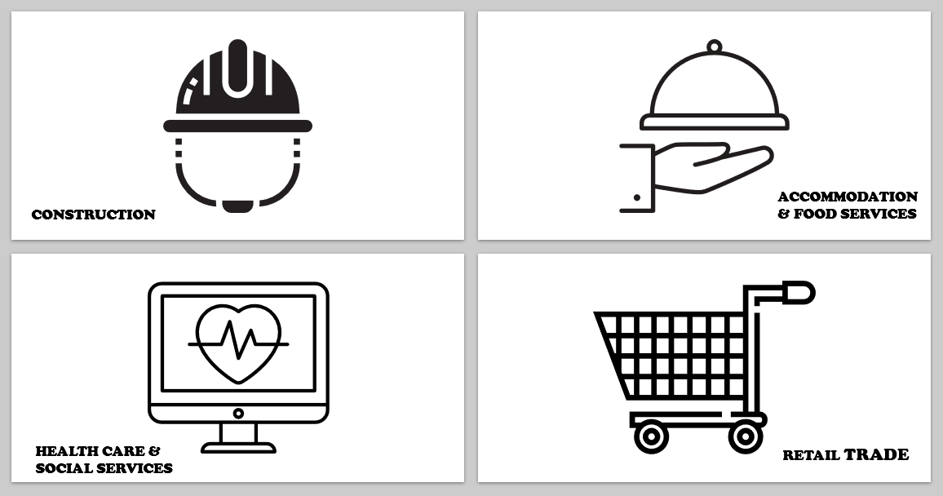

## priority workgroups

WorkSafe ACT will focus on ensuring the following workgroups are prioritised for activities under this Strategy:

* student workers and apprentices including international students
* young workers and apprentices with disability
* young LGBTIQ+ workers and apprentices
* young Aboriginal and Torres Strait Islander workers and apprentices, and
* young workers and apprentices that are culturally and linguistically diverse.

## EVALUATION

WorkSafe ACT is committed to evaluating and reporting activities in support of its Strategies. This information will be used to inform subsequent updates.

The Strategy will undergo evaluation at 12 and 24 months and a final evaluation report of activities and achievements will be released in the first quarter of 2024.

The progress of the Strategy will be reported in WorkSafe ACT’s Annual Report 2022-24 published on the website: [https://www.worksafe.act.gov.au](https://www.worksafe.act.gov.au/).

## Appendices

The data used to inform the decisions in this strategy were collated from a variety of sources.

The ACT workers’ compensation data was provided by CMTEDD. It contains all claims reported in the 2020-2021 financial year from the private sector, not only accepted claims.

The labour market data from the ABS can be accessed [on its website](https://www.abs.gov.au/statistics/labour/employment-and-unemployment/labour-force-australia-detailed/aug-2021#data-download). In this document, the September 2021 release of the *‘Labour Force, Australia, Detailed’* data sets were used. In referencing the ABS data, the table names have been included in the footnote.

In determining the priority industries, information on the WorkSafe “Young Workers” Fact Sheet was taken into consideration.

## Accessibility and the [National Relay Service](http://relayservice.gov.au/)

If you require a translator or interpreter, you can contact us through the [Translating and Interpreter Service](https://www.tisnational.gov.au/) (TIS) on [13 14 50](tel:131450).

If you are deaf, or have a hearing impairment or speech impairment, call [13 36 77](tel:133677) or visit [www.relayservice.gov.au](http://www.relayservice.gov.au/) to make an internet relay or captioned relay call.

Speak and Listen users’ can phone [1300 555 727](tel:1300555727) for assistance.

Internet relay users can connect with the National relay service (NRS) [here](https://nrschat.nrscall.gov.au/nrs/internetrelay).

1. WorkSafe Victoria, March 2021, [*Younger workers: Safety Basics*](https://www.worksafe.vic.gov.au/young-workers-safety-basics), accessed on 26/10/2021
2. Youthsafe, n.d., [*Young workers – risk, safety and injury*](https://youthsafe.org/work/#1627353566997-295ac06b-b8ac), accessed on 26/10/2021
3. MBA, April 2021, [*Supervision of Apprentices and Trainees*](https://mba.org.au/supervision-of-apprentices-and-trainees/), accessed on 26/10/2021
4. ABS (June 2021) *‘LM1 - Labour force status by Age, Greater Capital City and Rest of State (ASGS), Marital status and Sex, February 1978 onwards’*
5. Australian Human Rights Commission (AHRC) (2020), ‘*Respect@Work: National Inquiry into Sexual Harassment in Australia Workplaces’*, [link](https://humanrights.gov.au/our-work/sex-discrimination/publications/respectwork-sexual-harassment-national-inquiry-report-2020)
6. AHRC (2018), *‘Everyone’s business: Fourth national survey on sexual harassment in Australian workplaces’*, [link](https://humanrights.gov.au/our-work/sex-discrimination/publications/everyones-business-fourth-national-survey-sexual)
7. Australian Human Rights Commission (AHRC) (2020), [*Respect@Work: National Inquiry into Sexual Harassment in Australian Workplaces*](https://humanrights.gov.au/our-work/sex-discrimination/publications/respectwork-sexual-harassment-national-inquiry-report-2020)