

**GUIDANCE**NOTE

**MANAGING SILICA DUST AT CONSTRUCTION SITES**

This guidance note has been developed to raise awareness about the hazards and risks of inhaling respirable crystalline silica (RCS; also known as silica dust).

This guide is aimed at persons conducting business and undertaking (PCBUs) in the residential and commercial construction industry. It includes advice about a range of silica containing materials and products and how to control the risks when silica dust is generated from these. This guidance note also provides information about supporting your control measures with health and air monitoring.

Other guidance specifically for managing the risks of silica dust generated from engineered stone can be found on the WorkSafe ACT website.

## What is silica dust?

* Silica is a common naturally occurring mineral, also known as silicon dioxide. Silica can be found or manufactured in different forms, broadly divided into crystalline and non-crystalline (amorphous).
* The most common form of silica is quartz. Silica is found in some stones, rocks, sand, gravel and clay. Silica can also be found in:

|  |  |
| --- | --- |
| **Material or product** | **Percentage of crystalline silica** |
| Engineered stone products | Up to 92% |
| Sandstone | 70 to 90% |
| Granite | 25 to 60% |
| Ceramic tiles | 5 to 45% |
| Autoclaved-aerated concrete. panels, concrete bricks and pavers | 20 to 40% |
| Slate | 20 to 40% |
| Fibre-cement sheeting | 5 to 40% |
| Concrete | Up to 30% |
| Bricks | 5 to 15% |
| Marble | Up to 5% |

When natural stone or rock and other silica containing products are cut, crushed, drilled or sanded, dust is released. The very fine portion of the dust that is generated is known as respirable crystalline silica or silica dust.

Silica dust is 100 times smaller than a grain of sand, so, workers can breathe it in without knowing. The tiny dust particles can remain in the air for long periods after the larger, visible dust particles settle.

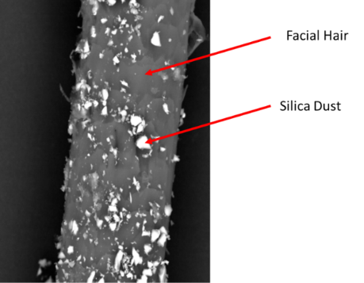Workers can breathe airborne silica dust into their lungs, and this can cause damage and disease. Silica dust can be airborne when a worker:

* cuts, chases or drills into concrete
* rips up existing concrete or bitumen roads
* jackhammers or saws stone or existing concrete, or
* excavates sites with sandstone, clay or granite.

Silica dust can also become airborne through housekeeping tasks like sweeping, when changing filters or dust collection bags or when a worker removes work clothes and personal protective equipment (PPE).

[image courtesy of Resources Safety & Health Queensland]

## What diseases does silica dust exposure cause?

Breathing in silica dust can cause a number of illnesses and diseases.

|  |  |
| --- | --- |
| **Chronic bronchitis** | Inflammation of the airways resulting in cough and irritation. |
| **Emphysema** | Breathlessness from destruction of the lung tissue and loss of surface area for the exchange of oxygen and carbon dioxide. |
| **Acute silicosis** | Extremely high dust exposures after just a few months or years can result in severe inflammation and an outpouring of protein in the lung. |
| **Accelerated and chronic silicosis** | Scarring and fibrosis of the lung tissue from repeated exposures. |
| **Lung cancer** | Occurs with heavy exposure to silica, with smokers having a higher risk. |
| **Kidney damage** | May require dialysis if severe. |
| **Scleroderma** | A disease of the connective tissue of the body resulting in the formation of scar tissue in the skin, joints and other organs of the body. |
| **Autoimmune diseases** | Diseases that result from the body attacking itself. |

Some of these diseases have a long latency period and do not have easily identifiable symptoms. Some of these diseases may not appear until years and sometimes decades after exposure stops. Others, especially after high levels of exposure to silica dust, can result in symptoms very soon after just one exposure.

Because both long and short-term exposures to silica dust can cause irreversible, and sometimes progressive, lung damage and diseases in other organs, all exposures to silica dust must be controlled. Exposure to silica dust must be managed:

* over the length of a shift, to make sure a worker’s total average exposure is low, and
* within a shift, to make sure short, high exposures do not occur.

## Who is at risk of exposure to silica dust?

The workers that are most at risk of exposure to silica dust are those who use power tools or mechanical equipment on silica containing stone or rocks and products that contain silica. This could include any worker who:

* uses a power tool to cut or modify engineered stone, for example fabricating and installing kitchen benchtops
* blasts, excavates, drills, cuts or tunnels into sandstone, clay or granite
* drills, cuts, saws or chases into concrete and brickwork, including drilling rigs
* cuts, grinds or drills bricks, autoclaved aerated concrete, pavers or tiles
* angle grinds, jackhammers, scabbles or chisels concrete
* sprays concrete (shotcreting)
* cuts in or chases new services into slabs or walls
* dismantles equipment or disposes of offcuts covered in silica dust
* demolishes buildings
* mixing cement, mortar, floor ardit or plaster, or
* cleans up the dust and debris created by the above activities, including dried concrete slurry and changing filters or dust collection bags.

It is important to ensure that all dusts generated through construction and demolition do not drift and pose an exposure risk to others at or around the workplace.

## How do I identify if silica dust is at my site?

As the PCBU, it is important for you to know what materials are being worked with at your site; these can be natural or man-made.

Where available, obtain and read the Safety Data Sheet (SDS) for the products that you work with and see if the components listed include quartz, cristobalite or crystalline silica. Some silica containing products do not need a SDS, but you may find information on a label warning of silica content or in the product information sheet or manufacturer’s website.

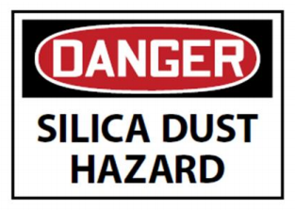If silica dust is generated from a natural source such as in tunnelling, excavating or drilling operations, you will need to seek alternative information about the likelihood of silica being present in the dust. For example, a Geotech report. [image courtesy of Safe Work Australia]

The manufacturers, importers and suppliers of products can tell you about the silica content of products and safe systems of using those products. You can also ask an occupational hygienist for advice.

## How do I manage the risk of silica dust at my site?

Eliminating exposure to silica dust is the most effective control measure for controlling the risk of exposure. Where exposure cannot be eliminated, any exposure to silica dust must be minimised so far as reasonably practicable. This includes managing the risk from short term or one-off tasks.

The risk can be managed through applying the hierarchy of controls, for example:

|  |  |  |
| --- | --- | --- |
| **Level 1** | Eliminate the risk | Use materials that do not contain crystalline silica |
| **Level 2** | Reduce the risk using substitution | Use materials with a lower crystalline silica content  Using fibre cement sheet sheers instead of circular saws |
| **Level 3** | Reduce the risk using isolation | Use automated machines,  Fully enclosed operator cabins, e.g. on earthmoving plant with high efficiency air filtration  Apply exclusion zones |
| **Level 4** | Reduce the risk using engineering controls | No dry cutting, use wet methods  Use on tool water suppression technology or dust extraction  Use well positioned local exhaust ventilation  Use H or M-class vacuums |
| **Level 5** | Reduce the remaining risk through administrative controls | Design shift rotations and limit task times  Use signage to warn of silica dust hazards in the area  Design housekeeping and cleaning policies  Prepare a safe work method statement (SWMS) |
| **Level 6** | Reduce the remaining risk with personal protective equipment | Provide respiratory protective equipment (RPE) with a suitable protection factor |

Managing the risk of exposure to silica dust includes considering:

* what activities will workers carry out?
* will these activities generate dust?
* who could be exposed and where?
* do you need to implement any control measures to minimise exposures?
* how often are equipment and tools inspected and maintained?
* how do your worker’s clean up?
* what training do workers need to undertake the work safely?

Managing the risk of exposure to silica dust needs a combination of high-level control measures (isolation, substitution and engineering controls) with administrative measures and, for most activities, personal protective equipment (PPE).

While wet methods significantly minimise the risk of exposure when compared to dry ones, it does not eliminate the risk of exposure to silica dust. A combination of local exhaust ventilation or dust collection and wet methods has been shown to significantly reduce airborne dust generation. RPE should still be considered, and all collected dust and slurry removed, especially before it dries and poses a dust risk.

As the PCBU, you can control the risk by:

* using products or materials containing less silica
* keeping dust generating activities physically separated from other work areas
* changing the way dust generating tasks are carried out, for example using wet methods
* using dust collection methods and equipment when using drills, routers and saws
* fitting large machinery (excavators and bulldozers) with cabs that have an air filtering system
* minimising the generation of airborne dust through planning cut sequences
* collecting dust as it is generated using:
* an industrial H-class vacuum cleaner with HEPA filter for engineered stone dust
* an industrial M-class vacuum cleaner with a HEPA filter for other silica containing dusts, or
* wet sweeping, and
* bagging and disposing of dust or slurry using a strong, durable bag or those provided with your dust extraction equipment.

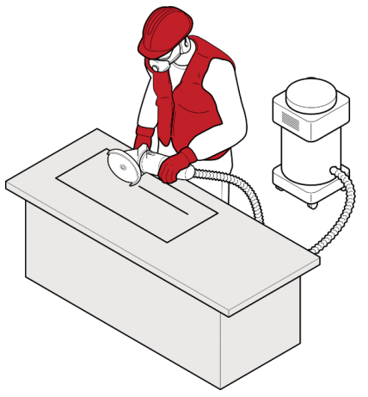As the PCBU, you can support these higher-level risk controls with signage and housekeeping policies. These policies should include maintenance schedules for equipment and filter changes according to the manufacturer’s instructions. These should also include how to dispose of the dust in your dust extraction systems (such as filters or bags), so they do not cause a secondary exposure risk when they are being changed or when bags of dust or slurry are disposed of.

You should provide decontamination spaces for dusty PPE and changing clothes, which can be supported by using coveralls or providing a laundering service, and designated dust-free areas for breaks, eating and drinking.

Remember that the controls you put in place may pose additional hazards, for example using wet methods can introduce a slip, trip and fall hazard. As the PCBU, you must ensure that the risks posed by these hazards are also managed.

[image courtesy of Safe Work Australia]

Encourage your workers to talk to you or their chosen representative about any concerns they have with their work and to promptly report any problems with their equipment or PPE.

## do i need a safe work method statement?

A safe work method statement (SWMS) is a document that sets out the:

* high-risk construction work activities to be carried out at a workplace
* hazards arising from these activities, and
* measures to be put in place to control the risks.

Generally, a SWMS is prepared by the builder for their workers, or by the subcontractor for their workers and themselves. A SWMS must be prepared by the PCBU in consultation with their workers (and, where relevant, their representatives such as a Health and Safety Representative or HSR) before carrying out the high-risk work.

A SWMS must be prepared before carrying out construction work that has a risk of exposure to silica dust. This is because silica dust results in a contaminated atmosphere and is therefore high-risk construction work under the WHS Regulation.

The purpose of the SWMS is to:

* identify the workplace hazards related to silica dust
* identify the risks to health and safety from the silica dust that is generated, and
* describe how the risk of exposure to silica dust will be managed, including:
* what controls will be used, and
* how the controls will be used.

More information about SWMS can be found in the *Code of Practice: Construction Work*.

## Training workers to work safely with silica dust

You must provide your workers with suitable training and ensure that they understand:

* the risks of working around silica dust
* the control measures in place
* how to use their PPE including respiratory protection, and
* what is required of them for health monitoring.

This may involve providing training in other languages.

Training for silica awareness should be nationally accredited and provided by a registered training organisation (RTO).

## what RPE should i provide for my workers?

|  |
| --- |
| Personal protective equipment (PPE) including respiratory protective equipment (RPE) must not be relied upon as a primary means of controlling exposure to silica dust. |

It must only be considered after implementing a combination of higher-level control measures like an on-tool dust vacuum extraction or water suppression. As the PCBU, it is your responsibility to provide suitable PPE for your workers and the tasks they carry out.

Workers who undertake tasks that generate silica dust should wear RPE that protects for dusts (or particulates) and has an appropriate assigned protection factor (APF) for any residual risks posed by silica dust that is generated by their work. Workers in the surrounding areas and workers who may work in the area after silica dust is generated should also be provided with suitable RPE, this includes RPE that is protective and comfortable for the wearer.

Where the silica concentration is lower in a product or material, a properly fitted P1 respirator or mask may be suitable. Where there is a lot of dust generated, such as cutting pavers or shotcreting, a P2 or half-face respirator should be considered. For tasks using wet methods, sometimes a full-face P2 respirator is more comfortable to wear. For high dust generation tasks such as during jackhammering or cutting cement with a grinder, there are P3 respirators and also positive air pressure respirators (PAPR) available that pump clean air into the breathing zone of the worker while they are working.

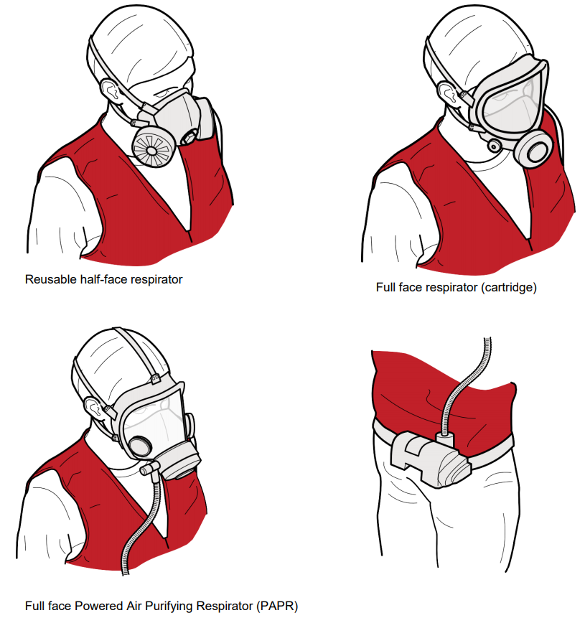

[image courtesy of Safe Work Australia].

It is critical that RPE is fit tested by a competent person, such as an occupational hygienist or qualified fit tester, for the individual worker wearing it to ensure that there is an effective seal. In most cases, this will mean your workers must be clean shaven. There are some full face and hood PAPRs that can be considered for those workers with facial hair.

It is critical that the RPE selected works in combination with other PPE a worker wears for a task or on a site. For example, the RPE must fit properly with hearing protection, hard hats and eye protection.

## What is involved in health monitoring?

PCBUs must provide and pay for health monitoring for all workers, where there is significant risk to the worker’s health because of exposure to silica dust. PCBUs must inform workers of the requirements for health monitoring and ensure appropriate training and equipment is provided and used.

Significant risk can be defined by how often the worker does tasks where they need to wear RPE. This is because the effective use of RPE relies on worker training and behaviour.

As the PCBU, you must provide health monitoring to a worker when they are required to wear RPE at any time for 30 days (or more) over a twelve-month period and the worker has undertaken (or will undertake) tasks that:

* involve materials or products that containing crystalline silica, and
* generate or disturb silica dust.

This means that if a worker is undertaking any task that requires RPE, that day counts towards the 30 days over twelve months. This is regardless of how long they wear the RPE or how often they are required to wear it during that day.

Health monitoring is supervised or carried out by a registered medical practitioner (doctor) who has experience in health monitoring for silica. For silica dust and due to the complex diagnosis of early disease caused by silica dust exposure, this could be a specialist occupational physician. Generally, testing will include a questionnaire, lung function tests and a chest X-ray or high-resolution computed tomography (HRCT). The doctor will decide what tests are needed based on:

* the type of work being undertaken
* the products being worked on and with,
* the worker’s exposure history, and
* any air monitoring records.

The doctor may ask to inspect the workplace as part of the health monitoring program. The PCBU should follow the recommendations of the doctor supervising health monitoring as to how often health monitoring should be done and what tests should be undertaken for each individual worker.

Health monitoring records are confidential and required to be kept for at least 30 years. PCBUs must provide a copy of the report to the worker as soon as the PCBU can, after it is obtained from the doctor. Health monitoring reports that include any advice that the worker has contracted a disease, injury or illness must provide a copy of the report to WorkSafe ACT as soon as possible.

For detailed information about health monitoring, see the Safe Work Australia website.

## What is involved in air monitoring?

On 1 July 2020, a new workplace exposure standard for silica dust came into effect in the ACT to better protect workers employed in the building, construction and stonemasonry sectors. The revised workplace exposure standard is an eight-hour time weighted average (TWA) of 0.05 milligrams per cubic metre (mg/m3). Under regulation 49 of the WHS regulations, this exposure standard must not be exceeded.

Air monitoring is required when you are unsure if you are exceeding the exposure standard, such as when you have implemented new controls or when selecting suitable RPE; or if you are trying to determine if there is a risk to the health of your workers or others at your workplace.

If you have implemented a combination of higher-level controls, such as wet cutting methods and dust extraction, and then also combined these with administrative controls and appropriately protective and fit tested RPE, in most cases, you can make a reasonable assumption that you have not exceeded the workplace exposure standard.

It is now well known that silica dust can affect the lungs at very low concentrations, and there is also generally no need to undertake air monitoring to determine if there is a risk to health; it can be assumed that silica dust poses this risk and health monitoring should be provided.

Air monitoring measures the amount of dust in a worker’s breathing zone. Air monitoring should be carried out by a competent person, such as an occupational hygienist. It must be carried out if the PCBU is unsure if the workplace exposure standard has been exceeded or if it is necessary to determine if there is a risk to worker’s health. [image courtesy of Safe Work Australia]

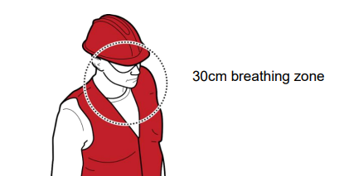The occupational hygienist will assess your workplace and advise on the type of air monitoring required and how often it should be performed. The occupational hygienist will provide you with an air monitoring report that will inform you if an exposure standard is being exceeded and recommend possible control measures that should be implemented to ensure workers are not exposed. Air monitoring reports must be kept for 30 years.

## WHEN DO I NEED TO NOTIFY WORKSAFE ACT?

If a serious event or dangerous incident (notifiable incident) occurs, a PCBU or whoever is in control must notify WorkSafe ACT.

In addition to this notification, WorkSafe ACT should be notified immediately when:

* there is a failure of physical isolation or engineering controls as this results in an uncontrolled emission of a substance (such as silica dust), or
* a health monitoring report shows an injury, illness or disease in a worker or where the doctor recommends a review of workplace controls.

## what will worksafe act inspectors be looking for when they visit my site?

WorkSafe ACT Inspectors will be looking at both safety and health related issues at your site. When it comes to silica dust, Inspectors will focus on:

* how you identified and communicated silica dust as a risk at your site
* SWMS for silica dust generating tasks
* if air monitoring has been undertaken, what the results show
* what combination of control measures you have in place and that they are working effectively
* housekeeping policies and methods and adequate facilities
* if you provide RPE, how you chose it, fit testing records and your schedule for replacing filters
* that workers have been provided health monitoring and health monitoring reports.

The checklist attached at Annex A will help you determine if you have identified and are managing the risk associated with silica dust. You should use this checklist to perform a self-assessment of your workplace.

The table at Annex B provides guidance on the control measures and other regulatory requirements that are available for specific tasks.

WorkSafe ACT Inspectors will use both documents to determine if you are complying with the [*Work Health and Safety Act 2011*](https://www.legislation.act.gov.au/View/a/2011-35/current/PDF/2011-35.PDF)*.*

## more information

Further information on silica dust can be found on the WorkSafe ACT [website](https://www.worksafe.act.gov.au/health-and-safety-portal/safety-topics/dangerous-goods-and-hazardous-substances/silica-dust).

The following information is available from the Safe Work Australia website:

[Working with silica and silica containing products](https://www.safeworkaustralia.gov.au/doc/working-silica-and-silica-containing-products-pdf-doc)

[Safe work method statement for high-risk construction work - information sheet](https://www.safeworkaustralia.gov.au/doc/safe-work-method-statement-high-risk-construction-work-information-sheet)

[Workplace exposure standards for airborne contaminants](https://www.safeworkaustralia.gov.au/exposure-standards)

[Guidance on the interpretation of workplace exposure standards for airborne contaminants](http://www.safeworkaustralia.gov.au/doc/guidance-interpretation-workplace-exposure-standards-airborne-contaminants)

[Health monitoring for crystalline silica](https://www.safeworkaustralia.gov.au/book/crystalline-silica-health-monitoring-guide)

## Managing the risks of silica dust: checklist

You can use this checklist to help guide your management of silica dust at your site.

This checklist follows the regulatory requirements under the Work Health and Safety Act and Regulations (2011).

Each workplace is different and the level and number of risks of exposure to silica dust will depend on your trade, tasks and the materials and products you use; there may be some questions that are not relevant for your workplace.

More information can be found on the WorkSafe ACT website, in the attached Guide and matrix or you can ask WorkSafe ACT a question at [worksafe@act.gov.au](mailto:worksafe@act.gov.au)

|  |  |  |
| --- | --- | --- |
| **Managing risks** | | |
| r34 | Has silica been identified as a hazard? |  |
| Has the PCBU identified all materials and products that contain crystalline silica? |  |
| r36 (3c) | Has the PCBU implemented one or more higher level control measures? |  |
|  | Is work with silica containing materials or products isolated? |  |
|  | Are workers performing work in the immediate vicinity of visible dust the inspector reasonably believes contains respirable crystalline silica (RCS)? |  |
|  | Are engineering controls implemented? |  |
|  | Are wet methods in use? |  |
|  | Are dust extraction methods used either on tool or local exhaust? |  |
| r40 (e) | Is there adequate ventilation to perform work? |  |
| r36 (4) | Are the higher-level controls supported by administrative controls? |  |
|  | Are there appropriate policies prepared?   * Housekeeping * Cleaning and disposing of slurry * Equipment maintenance |  |
|  | Is there signage? |  |
| r36 (5) | Is personal protective equipment provided? |  |
| r44 | Is it suitable to support higher order control measures? |  |
|  | Is the APF suitable? |  |
| r37 & 38 | Is there a schedule of review and maintenance for the control measures implemented? |  |
| r351 (s19) | Is the PCBU managing the risk of the hazardous chemical at the workplace? |  |
| **Respiratory protective equipment (RPE)** | | |
| r44(2) | Has RPE been provided for use by the PCBU (or another person) to control the remaining risk? |  |
| r44(3c) | Is RPE being worn or used by a worker(s)? |  |
| r44(2) and | Is the RPE provided suitable for the RCS risk? |  |
| r44(3ai) | Is the RPE provided consistent with that recommended by the safety data sheet (SDS) or product information sheet? |  |
|  | Does it have an appropriate assigned protection factor (APF)? |  |
| r44(3bii) | Does the PCBU have a policy in place to ensure filter changes are made at appropriate intervals? |  |
| r44(2) and r44(3aii) | If RPE is tight fitting, has a fit test been completed (in accordance with AS1715)? |  |
| r44(4) | Has the worker been provided training for the use, wearing, storage and maintenance of their RPE? |  |
| r46 | Is the worker wearing their RPE in accordance with their training? |  |
|  | Is the worker following clean shaven policies? |  |
|  | Is there evidence that the worker conducts a fit check when putting on and wearing their RPE? |  |
| **Air monitoring** | | |
| r49 | Can the PCBU demonstrate that the workplace exposure standard is not being exceeded? |  |
| r50 | Has air monitoring been undertaken to confirm workplace exposure standard has not been exceeded or to determine a risk to health? |  |
| **Safe Work Method Statements** | | |
| r299(1) | Was a SWMS prepared before work has commenced? |  |
| r299(2) & (3) | Is the SWMS compliant? |  |
| r300 | Is work being conducted in line with the SWMS? |  |
| **Check suitable engineering controls are used to manage risks from RCS** | | |
| r351(1) | Are water suppression and/or dust extraction methods being used? |  |
|  | Is it sufficient? |  |
|  | Is it well directed? |  |
|  | If water suppression is being used, is the mist controlled and slurry collected? |  |
|  | If dust extraction is used being used, is it capturing the majority of visible dust generated? |  |
|  | If dust extraction plant (vacuum cleaner/dust extraction unit) is being used, does the plant or plant filter system meet the requirements of at least M-class (H-class is also acceptable) as described in AS 60335.2.69? |  |
|  | Is a tool-mounted dust extractor fitted with a HEPA filter? |  |
| **Safety signs** | | |
| r353 | Has signage been erected? |  |
| **Health monitoring** | | |
| r368 | Has health monitoring been provided to all relevant workers? |  |
| r375 | Have workers been provided with a copy of their individual health monitoring report? |  |
| r376 | Have health monitoring reports been provided to WorkSafe ACT when they contain advice that test results indicate a disease, injury or illness or recommendations to take remedial actions? |  |
| **Primary duty of care – in consideration of all of the above:** | | |
| s19 (c) | Are safe systems of work established and reviewed? |  |
|  | Is it adequate to manage the risk? |  |
| s19 (f)  r 39 | Have workers been provided information, training, instruction and supervision necessary to protect all persons from risks to health and safety? |  |
|  | Is there evidence of training for working with silica? |  |
|  | Is there evidence of training for RPE? |  |
| s19 (g) | Is the health of workers and conditions at the workplace monitored for the purpose of preventing illness and injury? |  |

**Managing the risks of silica dust – matrix of control measures**

This matrix can be used as a guide for selecting and implementing control measures to manage the risk of silica dust at construction sites. The matrix combines common tasks and silica content of materials and products to provide examples of management approaches.

This matrix is only a guide, each workplace and task should be comprehensively assessed to determine the appropriate level of control.

**How to use the matrix**

Examples trades and tasks are provided in Table 1 below and can be used in reference to the matrix.

|  |  |
| --- | --- |
| Step 1: | Identify your trade, task and the percentage of silica in the materials or products that your workers will be using. |
| Step 2: | Select the trade task or percentage of silica in the materials or products that has the highest risk. |
| Step 3: | Consider and apply the matrix guidance in line with the highest risk trade, task or silica containing material or product |

If you have more than one task being undertaken or more than one type of material or product being used, applying the risk controls for the higher risk task or material/product will control the risk for the lower risk task or product/material.

For surrounding workers, consider lower-level risk controls for those outside the exclusion area. Where a worker is required to work within the exclusion area, they should wear the equivalent respiratory protective equipment as worn by the operator and health monitoring and other requirements should be considered.

You should seek expert advice where you are unsure of what the most effective combination of controls is for your task and workplace.

**Table 1: Risk category for tasks and trades.**

| **Risk category** | **Example trades** |
| --- | --- |
| **Red – High risk** | |
| Materials or products:   * Engineered stone * High content silica materials (generally greater than 50%) | |
| * dry cutting, sawing, grinding, drilling, polishing, scabbling of silica materials * all tasks using power tools on engineered stone * jackhammering * using handheld powered chipping tools * cutting concrete with a grinder * handheld grinding and sanding * anchor drilling rigs for rock and concrete piles * drilling of concrete walls and columns * walk-behind concrete cutting saws and floor grinders * cutting fibre-cement board with handheld power saws * handheld and stand mounted drilling (impact and rotary drills) * cutting of pavers * vertical cutting concrete floors * overhead drilling concrete ceilings and soffits * shotcreting * cutting, grinding, drilling autoclaved-aerated concrete/blocks | * stoneworkers * construction worker * demolition * plumbing * electrical * landscaping * carpentry * plastering * cabinet making * demolition * plant operators * concreting * formwork * mechanical services * renovations |
| **Orange – Medium risk** | |
| Materials or products:   * Silica content approximately 15% and up to 50% | |
| * mixing cement and mortar * cutting bricks, blocks and pavers * floor sweeping | * construction worker * demolition * bricklaying * landscaping * concreting * renderer plastering * post tension works * renovations |
| **Yellow – Low risk** | |
| Materials or products:   * Silica content less than 15-20% | |
| * vertical drilling wet concrete flooring * concrete render patching (including sanding) * hydrocutting and high-pressure water jetting * cutting porcelain, ceramic and natural stone tiles and benchtops * gyprock cutting, mixing compound and sanding. | * construction workers * demolitions * bricklaying * tiling * landscaping * hydro cutting * plastering * renovations |

| **Task/Product** | **COMBINATION of control measures and supporting requirements\*** | | | | | | | |
| --- | --- | --- | --- | --- | --- | --- | --- | --- |
| **Do I need isolation controls?** | **What cutting method should I use?** | **What dust collection or ventilation do I need?** | **What administrative controls I need?** | **Do I need to provide RPE and what kind?** | **Do I need to organise air monitoring?** | **Do I need to provide health monitoring?** | **What else do I need to do?** |
| **Red / Engineered stone and high content silica materials** | Yes:  Significant exclusion zones from other workers  RPE worn for surrounding workers | Wet only** | Local exhaust and/or  H-class on tool dust extraction | Signage  Housekeeping policy Maintenance policy for plant, equipment and PPE  Clean shaven policy for tight fitting RPE  Task scheduling | Yes:  APF 25-50 for operator | Yes, for control effectiveness and compliance as indicated | Yes, and consider exposure of surrounding workers | Notify regulator (health monitoring and failure of engineering controls)  Fit testing of RPE |
| **Orange / Silica content up to 50%** | Yes:  Significant exclusion zones from other workers with RPE worn for surrounding workers | Wet only** | Local exhaust and/or  H-class on tool dust extraction | Signage  Housekeeping policy Maintenance policy for plant, equipment and PPE  Clean shaven policy for tight fitting RPE  Task scheduling | Yes:  APF 25-50 for operator | Consider when changing controls | Yes, and consider surrounding workers | Notify regulator (health monitoring and failure of engineering controls)  Fit testing of RPE |
| **Orange / Silica content up to 25%** | Yes:  Exclusion zones with RPE worn for surrounding workers | Local exhaust or  H- or M-class on tool dust extraction  Where controlled, modification can be undertaken outdoors | Signage  Housekeeping policy Maintenance policy for plant, equipment and PPE  Clean shaven policy for tight fitting RPE | Yes:  APF 10-25 for operator | Notify regulator as indicated  Fit testing of RPE |
| **Yellow tasks / Silica content <15%** | Consider exclusion zones | Wet or  Dry with manual tools and dust capture | Local exhaust or  M-class on tool dust extraction  Where controlled, modification can be undertaken outdoors | Housekeeping policy Maintenance policy for plant, equipment and PPE | As indicated or as a backup for failure of higher-level controls | Control effectiveness only if RPE used on >30 days per year | Yes, if RPE used on >30 days per year | As indicated |

* The combination of control measures that you use should be selected informed by your risk assessment. Each control should compliment the combination, for example when using wet cutting methods, the dust collection or ventilation method should be appropriate to collect any mists that are generated.

** Cutting method should ensure that there is no uncontrolled dry cutting of silica containing materials and products.