MANAGING
WORK-RELATED VIOLENCE AND AGGRESSION
PLAN 2021-2023

BACKGROUND AND RATIONALE
On 6 October 2021, WorkSafe ACT launched its Strategy for Managing Work-Related Psychosocial Hazards 2021-23 (the Strategy). It was developed to align with WorkSafe ACT’s strategic framework and encompasses the priorities within the:
- Strategic Plan 2020-2024
- Statement of Operational Intent, and
- Compliance and Enforcement Policy 2020-2024.
The Strategy is the overarching framework that captures WorkSafe ACT’s approach to work-related psychosocial hazards and sets out the following key objectives:
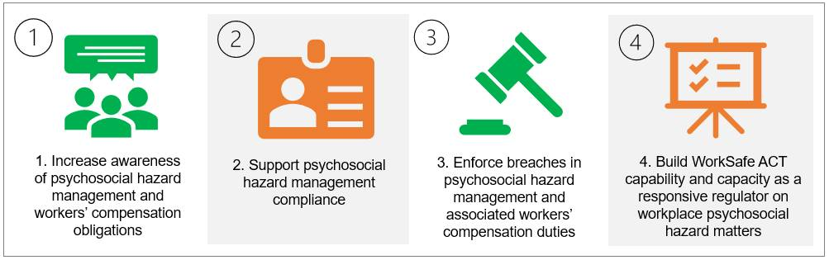
The Managing Work-Related Violence and Aggression Plan 2021-23 (the plan) is a supporting document that guides WorkSafe ACT’s approach to the identification of hazards and management of risks posed by work-related violence and aggression.

WORK-RELATED VIOLENCE AND AGGRESSION
Work-related violence is any incident where a person is abused, threatened or assaulted in circumstances related to their work. Manifestations of violence and aggression at work are both diverse and multifaceted and cover a broad range of actions and behaviours that pose a risk to physical and mental health and safety. The International Labour Organization state that violence and harassment at work refers to “a range of unacceptable behaviours and practices, or threats thereof, whether a single occurrence or repeated, that aim at, result in, or are likely to result in physical, psychological, sexual or economic harm, and includes gender-based violence and harassment”.
Work-related violence may include, but is not limited to, the following when an individual is carrying out their work duties:
- any form of assault, such as biting, spitting, scratching, hitting, kicking, punching, pushing, tripping, grabbing, or throwing objects
- any form of aggression
- intentionally coughing or spitting on someone
- any form of sexual assault or indecent physical contact
- intimidating behaviour that creates a fear of violence, such as stalking or threatening any form of assault including verbal threats and yelling
- sexual harassment
- online abuse of workers
- work-related violence and aggression due to employment, for example, a teacher who may be abused outside of working hours because they are known to be a teacher
- hazing or initiation practices aimed at new or young workers, or workers who identify as culturally and linguistically diverse, and
- domestic violence when this occurs at the workplace, including if the person’s workplace is their home.
Work-related violence can be perpetrated by a number of people in a workplace, including:
- a direct line manager in a workplace
- a manager or executive who does not have a direct supervisory role
- a co-worker
- a client
- a patient
- a customer, service user or a member of the public, or
- a student.
Work-related violence can be a one-off situation or systemic in certain occupations. It can also be through a public act of violence that impacts workers, such as an aggravated robbery.
Work-related violence is also known as occupational violence. WorkSafe ACT has adopted specific language to better capture as broad a definition as possible, including colleague on colleague violence. This aligns with Safe Work Australia’s guidance material and other jurisdictions and supports WorkSafe ACT’s regulatory priority of ensuring the health, safety and wellbeing of all the Territory’s workers.

PRIORITIES
In its 2021 Annual Statement on psychosocial health and safety and bullying in Australian workplaces, Safe Work Australia reported that during 2017-18, there were:
- 2,280 work-related harassment and/or workplace bullying workers’ compensation claims
- 1,130 claims for exposure to workplace or occupational violence, and
- 820 claims for exposure to a traumatic event.
Additional qualitative and quantitative data, including Salesforce, investigations and trend analysis and feedback from industry stakeholders, has identified the following workplaces in the ACT that should be prioritised for education and regulatory actions:

OBJECTIVES
The key objectives of this Plan are:
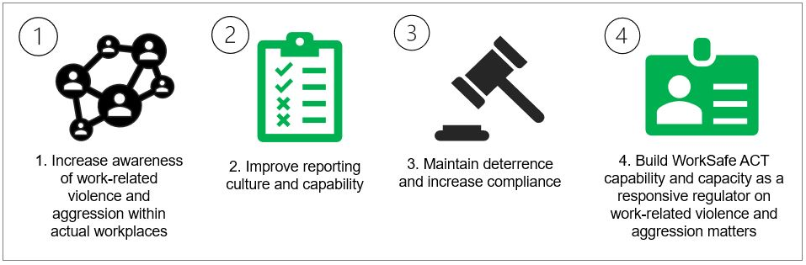
The four key objectives will be addressed holistically, bringing together building capability of duty holders to meet WHS obligations and building regulator capability and capacity to enforce compliance.
 | Objective | Supporting statement | Activities
1. | Increase awareness of work-related violence and aggression. | Duty holder awareness and knowledge of the hazards and risks of work-related violence and aggression, and the available resources must be improved before compliance can be achieved. | - Proactive communication and education campaigns using an approach addressing:  - relevant duties and legislative obligations  - awareness and understanding of hazards and risks, and  - the role of WorkSafe ACT.  - Promotion of existing resources, including those developed by Safe Work Australia.  - Development and promotion of new resources.
2. | Improve reporting culture and capability. | Underreporting contributes to a culture of acceptance and is a significant barrier to prevention. | - Development of a targeted communications campaign to:  - inform and educate duty holders of their obligations, and  - raise awareness of workers’ avenues for reporting.  - Engage and partner with key stakeholders to build trust and understand the importance of reporting incidents.
3. | Maintain deterrence and increase compliance. | Data, business led intelligence and anecdotal evidence indicates that work-related violence and aggression continue to present a hazard in ACT workplaces. | - Development of targeted resources to support safe design of workplaces and promoting a culture of zero tolerance.  - Proactive and triaged investigations of complaints and notifiable incidents.  - Full use of compliance tools, including:  - educating to facilitate compliance  - issuing of notices, and  - commencing a prosecution.
4. | Build WorkSafe ACT capability and capacity as a responsive regulator for work-related violence and aggression matters. | WorkSafe ACT requires the tools and resources to inform, educate and enforce. | - Targeted recruitment and broad inspectorate training to improve technical knowledge and skills on work-related violence and aggression.  - Develop and implement Standard Operating Procedures.

EVALUATION
WorkSafe ACT is committed to evaluating and reporting activities in support of its Strategies and plans. This information will be used to inform operational progress and subsequent updates.
The overarching Strategy will undergo evaluation at 12 and 24 months and a final evaluation report in the first quarter of 2024. Evaluation of the Plan will align and inform this evaluation.
The progress of the Strategy and Plan will be reported in WorkSafe ACT’s Annual Report 2022-24 published on the website: https://www.worksafe.act.gov.au/.

https://www.safeworkaustralia.gov.au/sites/default/files/2021-06/D21%209238%20Psychosocial_health_and_safety_and_bullying_in_australian_workplaces_6th_edition.pdf

