Silica Dust Project

2019

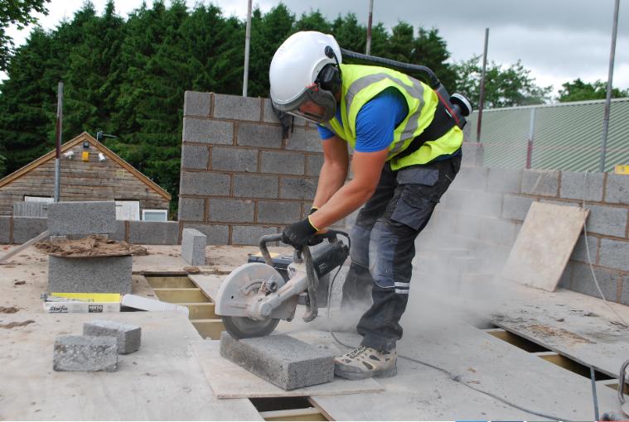

**Objective**

*To raise awareness on silica dust exposure, measure existing compliance and to reduce workplace exposures to hazardous chemicals and materials.*

**Purpose**

This project has been developed to tackle awareness and address concerns of an emerging trend of silicosis amongst the manufacturing and construction industries. The campaign will include a range of activities from improving guidance and information to measuring compliance. Of particular focus will be the safety of workers in the stone benchtop manufacturing and stone cutting businesses. The project will be expanded to other industries and specific processes such as demolitions and look at compliance within sub-set industries such as concrete cutting, tiling and other businesses working with or around stone or concrete products.

Inspectors from WorkSafe ACT will shortly conduct visits to all ACT workplaces that fabricate stone and artificial stone containing silica and will check and assist with compliance under relevant safety laws. The Inspector will concentrate on the following:

* Hazard identification, control and communication
* Engineering and isolation Controls
* Respiratory protective equipment
* Health monitoring

At present, PCBUs must provide health monitoring for workers if they carry out ongoing work using, handling, generating or storing crystalline silica and there is a significant risk to the worker’s health because of exposure (WHS Regulation section 368). Section 370 of the WHS Regulation provides the following minimum health monitoring requirements for crystalline silica:

* 1. demographic, medical and occupational history
  2. records of personal exposure
  3. standardised respiratory questionnaire to be completed
  4. standardised respiratory function test
  5. chest X-ray full size PA view

PCBUs must also ensure that workplace exposure standards are not exceeded under section 49 of the WHS Regulation. The Workplace Exposure Standard (WES) or Airborne Contaminants, published by Safe Work Australia, sets the workplace exposure standard for respirable crystalline silica at 0.1 mg/m3. Relevantly, this exposure standard is currently being reviewed by Safe Work Australia as a priority and it is likely that a reduction in this standard will be recommended.

Exposure to hazardous chemicals is preventable and without the proper controls serious injury and illness including death can occur.

Crystalline Silica has been identified as a priority chemical requiring the elimination and reduction of exposures in the workplace as part of the National WHS Strategy. As part of this program, targeted workplace visits will be implemented as identified in the priority industry groups based on the high risk industries and activities and the inspections will not only measure compliance but will provide tailored safety advice and assistance to those workplaces dealing with crystalline silica products.

**TARGET AREAS (Manufacturing & Construction)**

Examples of types of work in manufacturing and construction that are likely to be working with products containing crystalline silica.

|  |  |
| --- | --- |
| **CRYSTALLINE SILICA MANUFACTURING** | **CRYSTALLINE SILICA CONSTRUCTION** |
| *Foundries* | *Tunnelling* |
| *Stone Masonry* | *Construction Trades* |
| *Stone Benchtops* | *Tilers – Roof, wall/floor* |
| *General* | *Bricklayers* |
|  | *Demolition / Site Preparation* |
|  | *Landscape* |
|  | *Foundry* |

Exposure to high levels of respirable dust occurs when fine airborne dust is generated. Breathing in respirable dust containing crystalline silica can cause silicosis, a serious lung disease. The main symptoms of silicosis are breathlessness and chest pain. Over time it can become increasingly difficult to breathe leading to respiratory failure and death. There are different types of silicosis including acute (shorter diagnosis) and chronic silicosis which develops after many years (10 years or more) of exposure. Regularly breathing in silica dust may also cause chronic bronchitis.

This project will run throughout 2019 but is designed to target those priority industries and the stone benchtop businesses which will all be visited by end of April 2019.

**Methodology**

Stage 1. Worksafe ACT Inspectors will initially distribute information packs including the Inspector checklist to those workplaces that are involved in crystalline silica manufacturing. The information pack has also been distributed to HIA, MBA and relevant unions. The intent of stage 1 is to focus on those workers where exposure and subsequent risk is at its greatest. This timeline for this stage is:

* distribute information packs and checklists, arrange date for follow up visit – March to April 2019
* return to workplaces to conduct follow up inspections to assess compliance throughout April 2019.

Stage 2. Worksafe ACT Inspectors will distribute information packs including the Inspector checklist to those workplaces that are involved in construction industries from April to September 2019. This round of visits will follow the same methodology as stage 1, distribute the information packs and checklist, and arrange follow up visits to assess compliance.

Concurrently with stage 1 and 2 WorkSafe ACT will distribute information packs and address any instances of exposure reported to or observed by WorkSafe.

Stage 3. Reporting will be done on the compliance rates and information will be collected on the type of industry, business activities and the exposure rates to inform future programs. This will be completed in October 2019.