Strategy for MANAGING
work-related PSYCHOSOCIAL HAZARDS 2021-2023


Message from Jacqueline Agius, Work Health and Safety Commissioner
As the Territory’s Work Health and Safety Commissioner,
I strongly believe that every Canberran has the right to be safe at work, both physically and psychologically. This right to safety is enshrined in Territory WHS legislation and WorkSafe ACT inspectors enforce this every day.
Yet despite these rights, it is clear from the work of my inspectors and ACT workers’ compensation data, that many duty holders are not effectively managing work-related psychosocial hazards. Non-compliance is increasing harm to workers — harm that is entirely preventable.
It is morally and legally unacceptable for any employer to accept these hazards as ‘part of the job’ or for incidents of bullying, harassment or violence to be dismissed as being merely too hard to manage. And it
is inexcusable that workers such as women, those who identify as LGBTIQA+, those from culturally and linguistically diverse backgrounds, the young, people with disabilities and those in the casual workforce are bearing the burden of poor management and unsafe systems of work.
The Strategy for Managing Work-Related Psychosocial Hazards, the first of its kind for WorkSafe ACT, provides our regulatory principles of education, engagement and enforcement. It aims to build the maturity of organisations to identify psychosocial hazards and manage psychosocial risks, while highlighting known psychosocial hazards in the ACT, such as work-related violence and sexual harassment. Our enforcement priorities are clear and all duty holders in the ACT will be held to account. I have clear expectations for my own office — WorkSafe ACT itself will continue to develop its capacity and capability to drive duty holders
to achieve compliance.
As WHS Commissioner, I am committed to empowering the ACT to be a leader in the management of psychosocial hazards. This is a priority for me and for WorkSafe ACT, and it deserves to be a priority for
all ACT organisations.
I look forward to partnering with all workplace parties to understand and implement the best control measures available to manage psychosocial risks. The resulting health, safety and wellbeing outcomes
are immeasurable and will show the ACT to be what we all feel it should be — an Australian leader in the prevention of psychosocial harm.

BACKGROUND AND RATIONALE
WorkSafe ACT’s functions are set out in the Work Health and Safety Act 2011 (WHS Act), and include:
- promoting an understanding of and acceptance and compliance with the WHS Act or another territory law relating to work health and safety (WHS); and
- researching and development of educational and other programs for the purpose of promoting WHS.
Section 19 of the WHS Act provides that a person conducting a business or undertaking must ensure, so far as is reasonably practicable, the health and safety of workers.
The WHS Act defines health as both physical and psychological health

Psychosocial hazards are factors in the design or management of work that can lead to psychological harm. These can lead to an increase in the incidence of:
- bullying and harassment
- work-related violence
- sexual harassment, and
- work-related stress and psychological injury.
WorkSafe ACT’s Strategy for Managing Work-Related Psychosocial Hazards 2021-23 (the Strategy) is developed in alignment with WorkSafe ACT’s governance structure and encompasses the policies within:
- Strategic Plan 2020-2024
- Statement of Operational Intent, and
- Compliance and Enforcement Policy 2020-2024.
The Strategy is based on WorkSafe ACT’s data and business intelligence and the four high-level strategies that underpin its activities, as set out in the Strategic Plan 2020-2024:
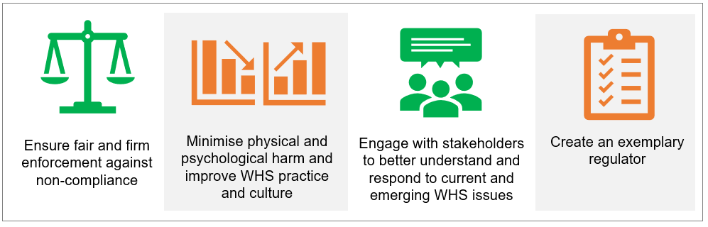

PURPOSE
This Strategy is the overarching document that captures WorkSafe ACT’s approach to work-related psychosocial hazards. It balances the need to support stakeholders to build capability and maturity to achieve compliance with WHS laws and the expectation that duty holders who contravene these laws are held to account.
The Strategy will guide the activities of WorkSafe ACT to educate, engage and enforce management of work-related psychosocial hazards in the ACT over the next three years. The Strategy also provides for targeted plans to address work-related violence and sexual harassment.
OBJECTIVES
The key objectives of the Strategy are:
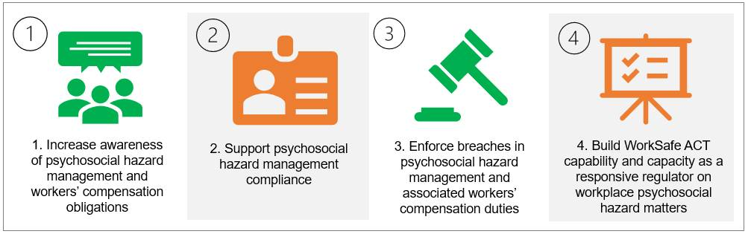
The four key objectives will be addressed holistically, and range across building industry awareness, understanding and ability to meet WHS obligations (also known as business maturity) and building regulator capability and capacity to enforce compliance.
Supporting the key objectives
Table 1 outlines the rationale for each objective and possible supporting activities. The activities for each objective are flexible and targeted, based on ACT specific data and experience. These activities can also be adjusted to incorporate any significant local or national advances, for example, WHS regulations for psychosocial hazards and risks or a Code of Practice.

Table 1: Rationale and possible activities to support key objectives
 | Objective | Rationale | Possible activities
1. | Increase awareness of psychosocial hazard management and workers’ compensation obligations. | Duty holder awareness and knowledge of existing duties and obligations to manage work-related psychosocial hazards needs to improve and mature before compliance can be achieved. | - Targeted engagement with:  - duty holders to benchmark business maturity to manage psychosocial risks, and  - other government agencies and workers’ compensation insurers on psychosocial matters.  - General and targeted awareness campaigns on:  - duties and obligations, and  - the role of WorkSafe ACT.
2. | Support psychosocial hazard management compliance. | Poor psychosocial hazard identification and management and compliance with workers’ compensation obligations in priority industries and small businesses is common.  In part, this can be attributed to a lack of clarity on how they can identify the hazards and effectively assess and control risks. | - Promotion of existing resources.  - Development and promotion of new resources to support business awareness, understanding and ability (business maturity) and/or implementation of any new psychosocial legislation.  - Development and promotion of prevention-focused materials:  - Managing Work-related Violence Plan, and  - Managing Sexual Harassment in the Workplace Plan.
3. | Enforce compliance in psychosocial hazard management and workers’ compensation duties. | The ACT community has the right to expect that WHS breaches will be consistently enforced in line with WorkSafe ACT’s Compliance and Enforcement Policy 2020-2024. | - Proactive compliance and enforcement campaigns.  - Develop and implement a triaging process for psychosocial hazard complaints and notifiable incidents.  - Full use of compliance tools, including:  - providing advice on compliance  - issuing Notices, and  - commencing prosecutions.
4. | Build WorkSafe ACT’s capability and capacity as a responsive regulator for work-related psychosocial hazards and risks. | WorkSafe ACT requires the appropriate capability and infrastructure to deliver the stated objectives. | - Targeted recruitment and broad inspectorate training to improve technical knowledge and skills on psychosocial matters.  - Develop and implement Standard Operating Procedures.

PRIORITy HAZARDS, industries and work groups
Priority hazards, industries and work groups for the Strategy are identified through a combination of qualitative and quantitative data, including Salesforce (WorkSafe ACT’s case management system), investigations and trend analysis and stakeholder feedback.
Priority hazards
The hazards identified for priority for this strategy include:
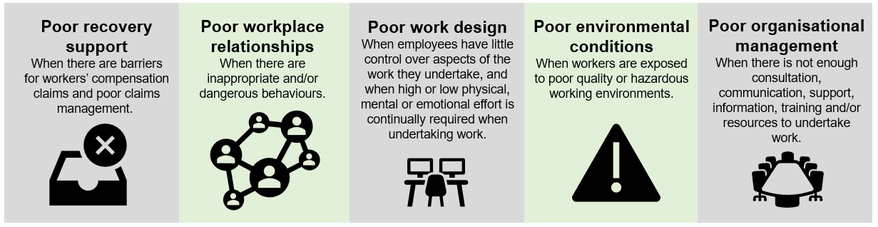
Priority industries

Priority work groups
Priority work groups have been identified as:
- businesses with less than 20 workers
- businesses with workers at greater risk of psychological harm, such as:
  - casual workers
  - labour hire workers
  - women, apprentices and young workers, and
  - culturally and linguistically diverse workers.
High-risk and poor performing workplaces identified during the Strategy may also be targeted for inclusion as priority work groups.

EVALUATION
WorkSafe ACT is committed to evaluating and reporting activities in support of its Strategies. This information will be used to inform subsequent updates.
The Strategy will undergo evaluation at 12 and 24 months and a final evaluation report of activities and achievements in the first quarter of 2025.
The progress of the Strategy will be reported in WorkSafe ACT’s Annual Report 2022-25 published on the website: https://www.worksafe.act.gov.au/

