

**GUIDANCE**NOTE

**LOCKING MECHANISMS ON TWO-POST VEHICLE HOISTS**

This guidance note has been developed to ensure that locking mechanisms on two-post vehicle hoist support arms are properly engaged to prevent vehicles slipping off the hoist.

**incident**

A vehicle has fallen from a two-post vehicle hoist in Victoria, injuring an automotive technician who was visiting the workplace. The hoist did not have its support arm locking mechanisms engaged to prevent the vehicle from slipping off. When the hoist moved, the vehicle fell onto the technician, causing him injuries which included a broken hip, eight broken ribs, a fractured sacrum, broken collar bone and heart tear.

**Contributing factors**

WorkSafe believes a range of factors could have contributed to this incident, and could lead to similar incidents occurring in future. These factors include the locking mechanisms on the two-post vehicle hoist:

* disengaging when the gear teeth on the device overlap *(Images 1 and 2*)
* failing to align because of excessive clearance between teeth *(Image 3*)
* having broken or excessively worn gear teeth *(Image 4*)
* having deformed teeth which prevent the teeth from engaging *(Image 4*), even when the gears are correctly aligned
* having partly engaged gears *(Image 5*)
* being overridden by technicians using the hoists *(Image 6*)

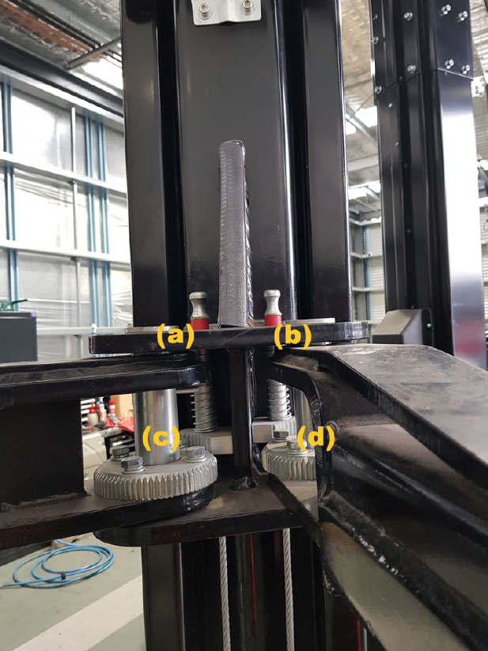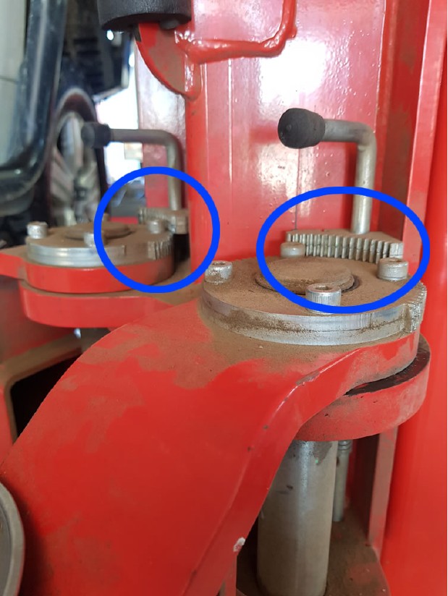

**Image 1**: Both locking mechanisms disengaged as gears overlap. Vehicle hoist arm can move if force is exerted on the vehicle.

***Image 3:*** Locking mechanisms gears too far apart. Locking mechanism gears do not engage due to excessive clearance between teeth . Vehicle hoist arms can move.

***Image 4:*** Gear teeth are broken

## 

***Image 6:*** Locking mechanism overridden.

Locking mechanism is disengaged and rotated out.

**Image 2:** Both internal locking mechanisms disengaged. Red locking mechanism disengagement indicators (a) and (b) are showing. Locking mechanisms disengaged as gears overlap (c) and (d). Vehicle hoist arm can move if force is exerted on the vehicle.

## 

**Image 4:** Gear teeth are broken

**Image 3:** Locking mechanisms gears too far apart. Locking mechanism gears do not engage due to excessive clearance between teeth. Vehicle hoist arms can move.

## 

**Image 5:** Internal locking mechanisms partly engaged.

**Image 6:** Locking mechanism overridden.

Locking mechanism is disengaged and rotatedout.

**The safety risks**

Locking mechanisms on two-post vehicle hoist arms are commonly known as automatic locking devices (ALD) as they automatically unlock when the vehicle is lowered to the workshop floor. That is, the gears disengage when the swing arms are fully lowered. However, ALD locks are not automatic when hoisting a vehicle (lifting) and require the hoist operator to manually ensure the gears engage effectively on hoisting prior to working on/under the hoisted vehicle.

**Recommended control measures**

### Pre-operational checks

Duty holders should develop and implement a system of daily pre-operational checks to ensure that all two-post vehicle hoists at the workplace are in a safe condition for use. These checks should be documented.

If pre-operational checks identify any of the issues *(Image 3)* the hoist should be locked out and tagged out pending works to rectify the fault/s being completed.

If pre-operational checks identify that the locking mechanism can be, or has been, lifted and rotated out of the way *(Image 6)*, the vehicle must be lowered to the shop floor immediately and the mechanism repositioned ensuring the gear teeth engage properly.

If the locking mechanism can be, or has been, lifted and rotated out of the way *(Image 6*), or the outer teeth of the gear on the cross-arm are damaged or deformed and the swing arms, when fully swung out or in, impact the gear teeth, the mechanism needs to be redesigned and you should consult with an appropriately qualified person.

### While a vehicle is raised

To ensure hoists are used safely, duty holders need to ensure that a suitably trained and competent person is available to perform the following when a vehicle is being lifted:

* Align the swing arm pads beneath the vehicle to be lifted.
* Raise the swing arms enough to engage the locking mechanisms.
* Manipulate or move the swing arms to ensure the locking gears have engaged properly.
* Check the vehicle is correctly centred on the rubber swing arm pads before lifting the vehicle.

### When lifting a vehicle

* Ensure the locking mechanism and any other safety features are not disengaged while a vehicle is raised on a two-post vehicle hoist.
* Check the locking device only disengages when the vehicle and hoist have been lowered back to the ground.

If a two-post vehicle hoist locking mechanism has not engaged correctly while supporting a vehicle, the lift needs to be stopped immediately and the vehicle lowered if it’s safe to do so. Also alert people working near the hoist to keep clear of the area. See below images of locking mechanisms on a two-post vehicle hoist *(Image 7*) and of a properly engaged locking mechanism *(Image 8*).

## 

**Image 8:** Locking mechanism on one swing arm. Locking Mechanism engaged as gears align. Vehicle hoist swing arm cannot

move.

**Image 7:** Top view of locking mechanisms on hoist arms – two locking mechanisms on one side of the vehicle hoist.

**Providing training and document risks**

* Provide workers using two-post vehicle hoists with the information, instruction, training and supervision they need to do their work safely and without risks to health. This includes information about operating, inspecting and maintaining the hoist, which may be found in the hoist operating manuals.
* Ensure that only suitably competent people use these machines.
* Document tasks and procedures not covered in the vehicle hoist operating manuals, for example, by using safe operating procedures and/or developing a job safety analysis (JSA). This information should cover specific hazards, risks and control measures to eliminate the risk of an incident occurring.

**Further duties**

Duty holders with management or control of a two-post vehicle hoist must eliminate risks associated with using the hoist, where it is reasonably practical to do so. If the risks cannot be eliminated, they must be reduced as much as possible. In addition, duty holders must keep a record of any inspection and maintenance carried out on a two-post vehicle hoist for the time they manage or control the plant.

**Further information**

* AS 1418.9-1996 Cranes (including hoists and winches) - Vehicle Hoists
* AS 2550 Cranes, hoists and winches – Safe Use
* AS 1418.1: Cranes, hoists and winches – General Requirements