MANAGING work-related sexual harassment
PLAN 2021-2023

BACKGROUND AND RATIONALE
The Managing Work-related Sexual Harassment Plan 2021-23 (the plan) is a targeted approach to support psychosocial hazards management in ACT workplaces over the next three years. The plan will do this by guiding the activities of WorkSafe ACT to educate, engage and enforce issues related to sexual harassment (also known as gender-based violence and harassment).
This plan has been developed under the Strategy for Managing Work-Related Psychosocial Hazards
2021-23 (the Strategy). The Strategy is the overarching framework that captures WorkSafe ACT’s approach to psychosocial hazards, which includes dedicated plans to address sexual harassment and work-related violence. The objectives of the strategy are to:
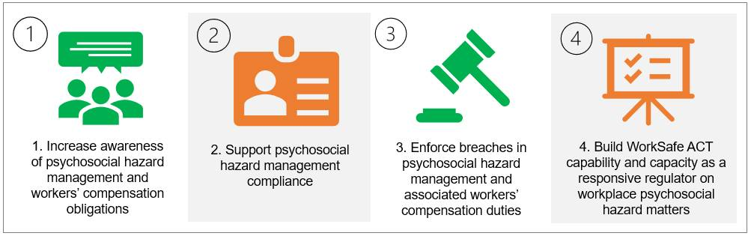
The Strategy and plan were developed to align with WorkSafe ACT’s strategic framework and encompasses the priorities within the:
- Strategic Plan 2020-2024.
- Statement of Operational Intent.
- Compliance and Enforcement Policy 2020-2024.

Sexual harassment
Sexual harassment impacts all workplaces across the ACT. Work-related sexual harassment is preventable.
All workers have the right to work in an environment that is safe and free from sexual harassment.
All persons conducting a business or undertaking (PCBUs) have an obligation to eliminate or manage the health and safety risks of work-related sexual harassment.
Sexual harassment is unwelcome conduct of a sexual nature, which makes a person feel offended, humiliated, or intimidated. Sexual harassment may be physical, verbal, or non-verbal.
Examples of work-related sexual harassment include:
- physical violence, touching or unnecessary close proximity
- comments and questions about appearance, lifestyle, or sexual orientation, and
- whistling, sexually suggestive gestures and displays of sexual material.
Sexual harassment is not always obvious, and it can be a one-off event, repeated, or continuous. It can include a behaviour that affects someone who is exposed to it or witnesses it, for example overhearing a conversation or seeing sexually explicit material in the workplace.
Sexual harassment can happen in a variety of settings, including in person, over the telephone or online.
It can happen at work-related activities such as conferences, visiting a client’s home and at work-related social activities. It might come from a supervisor or managers, other workers, contractors or from customers or clients.
In some situations, sexual harassment may overlap with work-related gendered violence, work-related violence, or work-related bullying. Complex workplace situations may include behaviours that make these difficult to distinguish.
Work Health and Safety duties in relation to sexual harassment
WorkSafe ACT’s role is to regulate work-related sexual harassment by ensuring PCBUs comply with their duty to provide and maintain a healthy and safe working environment.
WorkSafe ACT recognises that sexual harassment is a psychosocial hazard that can cause psychological or physical harm.
The impacts of sexual harassment
Sexual harassment can cause physical and psychological harm to the person experiencing or witnessing the behaviour. Sexual harassment can lead to:
- feelings of isolation, social isolation, loss of confidence and withdrawal
- physical injuries because of assault
- stress, depression, anxiety, and post-traumatic stress disorder (PTSD), and
- illness such as cardiovascular disease, musculoskeletal disorders, immune deficiency, and gastrointestinal disorders.
Work-related sexual harassment can have significant social and economic impacts on workers, PCBUs, and the wider community. It is estimated that workplace sexual harassment cost the Australian economy approximately $3.8 billion in 2018 alone.

Issues
WorkSafe ACT has identified three key issues relating to regulating sexual harassment in the ACT. These issues are drawn from qualitative and quantitative data, including Salesforce, investigations and trend analysis and feedback from industry stakeholders. Additional issues have been taken from the evidence and recommendations in the Australian Human Rights Commission report of the National Inquiry into Sexual Harassment in Australian Workplaces (the Respect@Work report).
- Gap in knowledge that sexual harassment is a WHS issue
There is limited understanding of sexual harassment as a WHS issue. This gap in the public perception is recognised in the Respect@Work report. The report highlighted that WHS laws are an underutilised opportunity to prevent and address work-related sexual harassment.
The legislative framework for reporting sexual harassment can be difficult to navigate in the ACT. Sexual harassment can be a criminal issue, a human rights issues, a work health and safety issue or an industrial relations issue. WorkSafe ACT acknowledges the challenges in navigating these separate but often overlapping legislative schemes.
- Data collection
There is no uniform approach to the collection and reporting of data related to sexual harassment in Australia. In the ACT, where data does exist, the number of sexual harassment related matters are low. Some possible reasons for this include:
- WHS jurisdictions, to date, have not dealt with sexual harassment as a focus of their work
- the complaint may be recorded under another category, for example bullying, and
- sexual harassment claims are underreported.
Initiatives aimed at improving data collection will provide the evidence base to inform guidance and support to duty holders and to develop regulatory policy.
- Internal capability
Historically WHS regulators have focused on physical harm and risks. WorkSafe ACT recognises the need to continue building its internal capabilities and strategic approach to effectively regulate work-related psychosocial harm and sexual harassment.

PRIORITy industries and groups
WorkSafe ACT operates across all industries in the ACT and must ensure interventions are targeted and effective.
The Australian Human Rights Commission (AHRC) national survey in 2018 found that 33% of respondents who had been in the workforce in the last five years experienced sexual harassment.
Drivers of sexual harassment
Women are significantly more likely to experience sexual harassment than men. Other groups with an increased likelihood of experiencing sexual harassment include:
- workers under 30 years of age
- workers who identify as LGBTIQA+
- Aboriginal and Torres Strait Islander workers
- workers with a disability
- workers from culturally and linguistically diverse backgrounds
- migrant workers or workers holding temporary visas, and
- people in insecure working arrangements.
The risk of experiencing harm from sexual harassment increases when a person faces multiple forms of discrimination.
Sexual harassment is more prevalent in some workplaces than others. A range of factors have been found to increase the risk of sexual harassment. These include workplaces which are male dominated, for example, the construction and mining industries. Factors which may increase the risk of sexual harassment include:
- the gender ratio and the over-representation of men in senior leadership roles
- the nature of the work being considered ‘non-traditional’ for women and the masculine workplace culture
- workplaces which involve a high level of contact with third parties, including customers, clients, or patients; for example, the retail and hospitality sectors, and the health care and social assistance industry, and
- workplaces that are organised according to a hierarchical structure; for example, in police organisations, the Australian Defence Force, and the medical and legal professions.
The following industries will be the focus of this plan to address work-related sexual harassment.

OBJECTIVES
The key objectives of the plan are to:
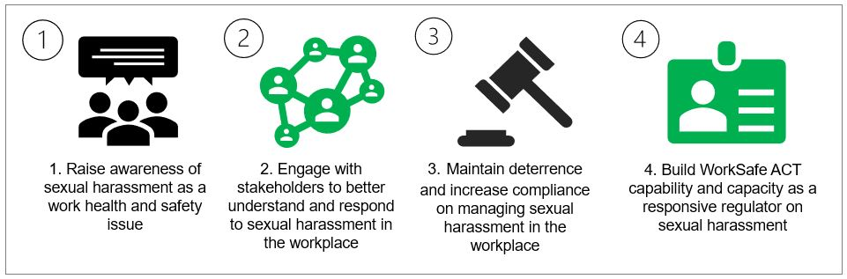
Table 1 outlines the rationale for each objective and possible supporting activities.
 | Objective | Rationale | Activities
1. | Raise awareness of sexual harassment as a work health and safety issue. | There is a gap in public knowledge on the role WorkSafe ACT plays in dealing with work-related sexual harassment. | - Develop and maintain a dedicated webpage on sexual harassment.  - Develop and deliver multimodal communication and education campaigns on sexual harassment.  - Promote existing resources, including those developed by other jurisdictions.  - Develop and promote new resources on sexual harassment and gender-based violence.
2. | Engage with stakeholders to better understand and respond to sexual harassment in the workplace. | Understanding the barriers to reporting and responding to sexual harassment is key to better regulating work-related sexual harassment. | - Engage and partner with key stakeholders in a variety of formats to understand the barriers to preventing sexual harassment in the workplace.
3. | Maintain deterrence and increase compliance. | WorkSafe ACT aims to secure compliance in line with our compliance and enforcement policy. This is achieved through effective and appropriate monitoring and enforcement. | - Develop targeted resources to support the safe design of workplaces and promote a culture of zero tolerance.  - Develop and deliver proactive and triaged investigations of complaints and notifiable incidents.
4. | Build WorkSafe ACT capability and capacity as a responsive regulator on sexual harassment. | WorkSafe ACT requires the tools and resources to inform, educate and enforce. | - WorkSafe ACT staff undertake training on gender-based violence and sexual harassment.  - Develop Standard Operating Procedures.  - Complete a review of data collection and information sharing mechanisms.

EVALUATION
WorkSafe ACT is committed to evaluating and reporting activities in support of its Strategies and plans. This information will be used to inform operational progress and subsequent updates.
The overarching Strategy will undergo evaluation at 12 and 24 months and a final evaluation report in the first quarter of 2025.
The progress of the Strategy and Plan will be reported in WorkSafe ACT’s Annual Report 2022-25 published on the website: https://wwwworksafe.act.gov.au/.

Deloitte Access Economics, The Economic Costs of Sexual Harassment in the Workplace (Final Report, February 2019).
Workplace sexual harassment | Safe Work Australia
Australian Human Rights Commission report of the National Inquiry into Sexual Harassment in Australian Workplaces (the Respect@Work report).
WorkSafe ACT, Strategy for Managing Work-related Psychosocial Hazards 2021-2023.

