

**GUIDANCE**NOTE

**HIGH-LOW LIFTS**

This guidance note raises awareness about using high-low lifts in the ACT.

A high-low lift is where multiple loads are slung by a crane in a vertical configuration. They are also known as Christmas tree lifts or multiple vertical lifts.

Lifting operations for tower and mobile cranes performing high-low lifts has been the subject of much debate about the safety of the operation and whether it is consistent with legislative requirements. At present, there is no explicit coverage in Work Health and Safety (WHS) legislation or under a Code of Practice in the ACT that deals with the practice of high-low lifts.

Australian Standard AS3775.2:2014 stipulates that dual independent loads or separately slung loaded sling are NOT to be used where the loads are slung to different heights.

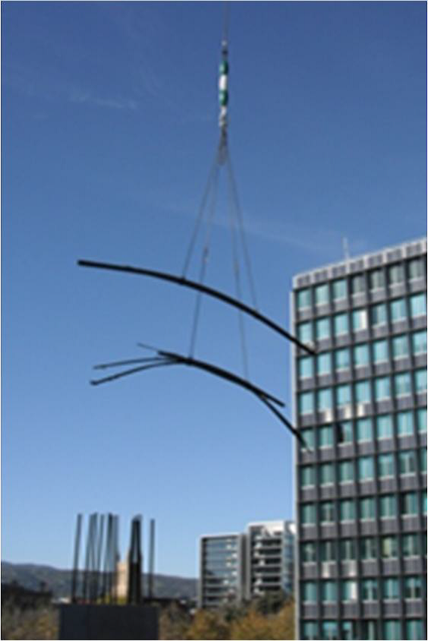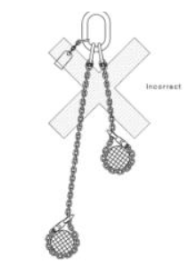

Lifting operations are only conducted by High-Risk Work Licence holders. Licence holders perform the task using appropriate control measures and under site specific safe work method statements (SWMS).

Regulation 36 of the [*Work Health and Safety Regulation 2011*](https://www.legislation.act.gov.au/View/sl/2011-36/current/PDF/2011-36.PDF) stipulates the hierarchy of control measures that must be followed when managing a workplace hazard or risk. For high-low lifts, this is supported by regulation 219 where a PCBU must ensure that loads are lifted or suspended in a way that ensures that the load remains under control during the activity.

**What are the risks?**

The use of high-low lifts poses an increased risk of injury to persons (mainly the dogman) working under a suspended load whilst attaching or landing the next load. The risks are increased due to the requirement of workers to be physically positioned under the top load during launch, landing and recovery.

There are also additional hazards as there are two loads in close proximity (especially during landing) that result in the load not being controlled during the lift activity.

**What are the control measures?**

To mitigate the risks of high-low lifts, the first control measure that must be considered is elimination. This means high-low lifts are not used at all. if this is a reasonable option at the worksite, then high-low lifts must be eliminated and only single load lifts used.

It is recognised that high-low lifts reduce the number of lifts undertaken during construction work. However, the amount of time saved by using high-low lifts is likely to be marginal at best.

As the PCBU, you must also ensure you meet the requirements of ensuring nobody is under a suspended load and that all loads are controlled. It is the opinion of WorkSafe ACT that a high-low lift does not meet these requirements.

**What will WorkSafe ACT inspectors be looking for?**

WorkSafe ACT inspectors will be checking that worksites that conduct lifts by crane are meeting all provisions of the WHS laws and meeting their due diligence obligations to keep their workers safe so far as reasonably practical to do so.

WorkSafe’s view is that to meet due diligence requirements and comply with the provisions of regulations 36 and 219 of the [*Work Health and Safety Regulation 2011*](https://www.legislation.act.gov.au/sl/2011-36/default.asp), high-low lifts should not be undertaken.