Strategy to prevent

work-related

Musculoskeletal Disorders
2022-2024

BACKGROUND AND RATIONALE
WorkSafe ACT’s functions are set out in the Work Health and Safety Act 2011 (WHS Act), and include:
- providing advice and information on work health and safety (WHS) to duty-holders and the ACT community
- promoting and supporting education and training on matters relating to WHS, and
- fostering a cooperative and consultative relationship between duty-holders and the persons to whom they owe duties and their representatives in relation to WHS matters.
Section 19 of the WHS Act provides that a person conducting a business or undertaking (PCBU) must ensure, so far as is reasonably practicable, the health and safety of workers. This includes a range of hazards and risks including preventing musculoskeletal disorders caused by work.
What are musculoskeletal disorders?
Musculoskeletal disorders (MSDs) include a wide range of inflammatory and degenerative conditions affecting the muscles, tendons, ligaments, joints, peripheral nerves and supporting blood vessels.
In Safe Work Australia’s National Dataset for Compensation-Based Statistics, MSDs are categorised into traumatic joint/ligament and muscle/tendon injuries (MSD injuries) and musculoskeletal and connective tissue diseases (MSD diseases).
MSD injuries include:
- trauma to joints and ligaments (e.g. sprains, tears, and dislocation)
- trauma to muscles and tendons (e.g. strains and tears), and
- soft tissue disorders due to trauma or unknown mechanisms.
MSD diseases include:
- joint diseases (arthropathies) and other articular cartilage diseases (e.g. inflammatory or infectious arthritis, acquired musculoskeletal deformities)
- spinal vertebrae and intervertebral disc diseases and dorsopathies (e.g. back pain, sciatica, neck pain, disc degeneration)
- diseases involving the synovium and related tissue (e.g. synovitis, tenosynovitis)
- diseases of muscle, tendon and related tissue (e.g. non-traumatic muscle or tendon strain, tendinitis, epicondylitis), and
- other soft tissue diseases (e.g. bursitis, occupational overuse syndrome).
The causes of MSDs
Work-related MSDs often involve a complex interaction between several distinct causal risk factors. These include:
- physical factors such as repetitive tasks, heavy lifting, adverse postures
- psychosocial factors such as low control/demand, low supervisor support, low recognition, and
- organisational factors such as high workloads, night shifts.
National Data
The economic and health burden of work-related MSDs in Australia is significant: In 2012-2013, the estimated annual cost of work-related MSDs to the Australian economy was more than $24 billion.
In 2019-20, 58% of serious workers’ compensation claims were for MSDs (38% MSD injuries, 18% MSD diseases). MSDs have long been the most common source of serious workers’ compensation claims in Australia. Between 2009–10 and 2013–14, there were 360,180 serious MSD claims, accounting for 60% of all claims during the period. Of the serious MSD claims during this period, MSD injuries accounted for 76% and MSD diseases for 24%.
As well as resulting in more serious claims than any other of type of injury/disease, MSDs have the greatest frequency rate (number of serious workers’ compensation claims per million hours worked) of any type of injury/disease in Australia. The median work time lost for serious MSD claims was 6 weeks in 2015-2016.
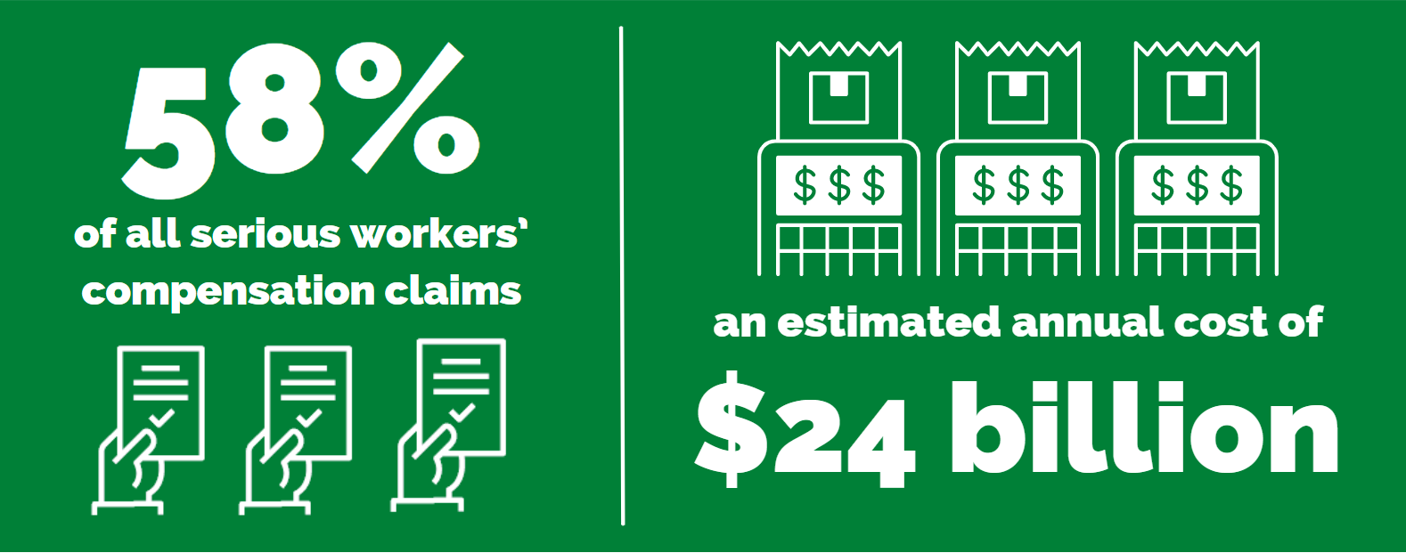
Frequency rate data by occupation is not available for the ACT. The occupation groups with the highest frequency rate of MSD claims nationally are:
- labourers (11.3),
- community and personal service workers (9.5), and
- machinery operators and drivers (8.4).
The occupation sub-groups with the highest frequency rates are:
- health and welfare support workers (15.8)
- defence force members, fire fighters and police (15.0), and
- personal carers and assistants (14.7).
ACT Data
In the ACT, MSD claims comprised of 57% of all accepted private sector workers’ compensation claims lodged between 2017-2018 and 2020-21. Of these claims, 69% of were for MSD injuries and 31% were for MSD illnesses.
The most common MSD claims by nature of injury/disease were:
- soft tissue injuries due to trauma or unknown mechanisms (52%), and
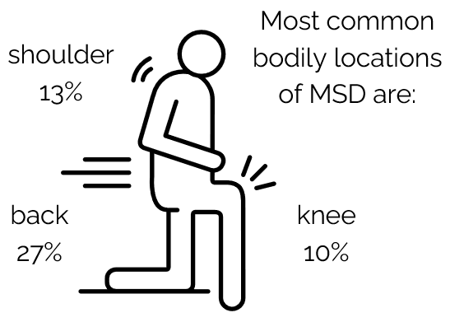
- non-traumatic muscle or tendon strain (21%).
Work-related MSDs can arise from exposure to a single, primary mechanism or multiple, secondary mechanisms over long periods of time. When workers’ compensation data are coded, only the primary mechanism of each injury or disease is recorded. This means that secondary mechanisms are not captured. It is important to consider this limitation when interpreting statistics on the mechanisms of MSDs.
Labourers were recorded as comprising only 5% of the ACT’s workforce in the 2016 census, so are greatly overrepresented in the MSD claims data. The representation of technicians and trades workers and community and personal service workers in the MSD claims statistics is closer to their representation in the ACT’s workforce (Technicians and trade workers comprised 9.6% of Territory workers and community and personal service workers 10.6% of workers in the 2016 census).
The occupation sub-groups in the ACT with the greatest number of claims were:
- other labourers (15%)
- carers and aides (10%)
- construction trades workers (6%), and
- sales support workers (5%).
Strategic alignment
WorkSafe ACT’s Strategy to Prevent Work-Related Musculoskeletal Disorders (the Strategy) is developed in alignment with WorkSafe ACT’s governance structure and encompasses the priorities within the:
- Strategic Plan 2020-2024
- Statement of Operational Intent, and
- Compliance and Enforcement Policy 2020-2024.
In particular, in the Strategic Plan, WorkSafe ACT aims to reduce the incidence rate of claims for musculoskeletal disorders resulting in one or more weeks off work by at least 30%.
The Strategy is informed by WorkSafe ACT’s data and business intelligence and the four high-level strategies that underpin its activities, as set out in the Strategic Plan 2020-2024.
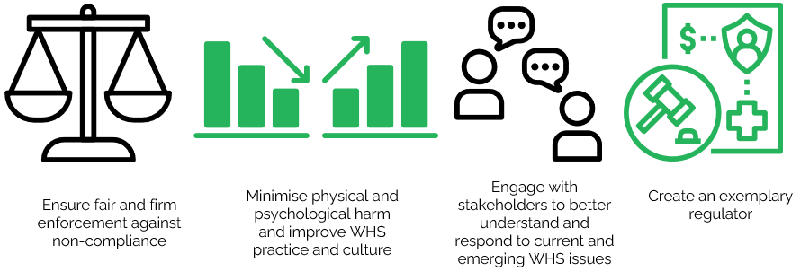

PURPOSE
This Strategy is the overarching document that captures WorkSafe ACT’s approach to preventing MSDs in ACT workplaces. The Strategy will guide the activities of WorkSafe ACT to educate, engage and enforce management of MSD prevention in the ACT over the next two years.

OBJECTIVES
The key objectives of the Strategy are:
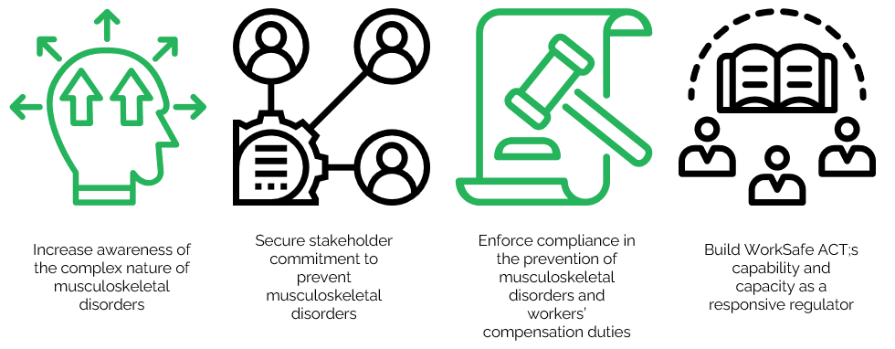

Supporting the key objectives
Table 1 outlines the rationale for each objective and possible supporting activities. The activities for each objective are flexible and targeted, based on ACT specific data and experience.
Table 1: Rationale and possible activities to support key objectives
 | Objective | Rationale | Possible activities
1. | Increase awareness of the complex nature of musculoskeletal disorders. | Stakeholder awareness of the interaction between physical, psychosocial, organisational, and personal risk factors will build knowledge of the obligations to manage the hazards that can lead to MSDs and drive improved health outcomes. | Use available communications platforms to optimise the access of information and practical tools and improve networking channels amongst stakeholders.  Targeted engagement with:  - duty holders about managing the risks that lead to MSDs, and  - general and targeted awareness campaigns on:  - duties and obligations, and  - the role of WorkSafe ACT.
2. | Secure stakeholder commitment to prevent musculoskeletal disorders. | Sharing evidence-based research and best industry practices will mean stakeholders are equipped with practical ways of achieving success in preventing MSDs. | Collaboration with stakeholders including other WHS regulators, ACT government agencies, industry groups, non-government organisations and research bodies to:  - promote existing resources, and  - develop and promote resources that will support PCBUS, understanding and ability to manage MSD hazards.
3. | Enforce compliance in the prevention of musculoskeletal disorders and workers’ compensation duties. | The ACT community has the right to expect that WHS breaches will be consistently enforced in line with WorkSafe ACT’s Compliance and Enforcement Policy 2020-2024. | - Proactive compliance and enforcement campaigns.  - Full use of compliance tools, including:  - providing advice on compliance  - issuing Notices, and  - commencing prosecutions.
4. | Build WorkSafe ACT’s capability and capacity as a responsive regulator. | WorkSafe ACT needs the appropriate capability and infrastructure to deliver the stated objectives. | - Broad inspectorate training to improve technical knowledge and skills about the prevention of MSDs.

PRIORITy HAZARDS, industries, OCCUPATIONS, and work groups
Priority hazards, industries, occupations, and work groups for the Strategy are identified through analysis of Safe Work Australia Reports, ACT private sector workers’ compensation claims data, Salesforce (WorkSafe ACT’s case management system), investigations, and stakeholder feedback.

hazards
The most common hazard likely to cause MSDs is lifting heavy or bulky loads. Repetitive work, reaching, twisting or working in small spaces also pose risks of MSDs.

industries
MSDs are prevalent in all industries. However, at the national level, the industries with the highest national MSD claim frequency rates are healthcare and social assistance (7.1), transport, postal and warehousing (7.0), manufacturing (5.4), and agriculture, forestry and fishing (5.0), . The ACT’s workforce profile differs to the national profile with limited manufacturing, agriculture, forestry and fishing.
In the ACT. the industries with the greatest number of accepted private sector MSD claims between 2017-18 and 2020-21 were:
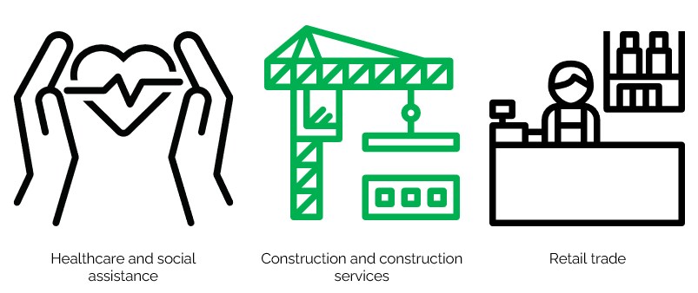
Healthcare and social assistance (21%)
- Approximately 11% of workers in the ACT were employed in healthcare and social assistance during this period.
- Over 70% of healthcare and social assistance claims were concentrated in residential care services and social assistance services.
Construction (19%)
- Approximately 7% of all ACT workers were employed in construction during this period.
- Approximately 70% of construction claims were in construction services (with a majority of these concentrated in building structure services and building installation services).
Retail trade (13%)
- Approximately 7% of all ACT workers were employed in retail trade during this period.
- Supermarkets and grocery store claims contributed almost 40% of retail trade claims.

OCCUPATIONS
In the ACT the occupation groups with the greatest number of MSD claims between 2017-2018 and 2020-21 were:
- labourers (25%)
- technicians and trades workers (19%), and
- community and personal service workers (16%).

Workgroups
The frequency rate of MSD claims is higher among older workers. The total frequency rates for MSD claims for men and women are similar, but young male workers have considerable higher frequency rates.
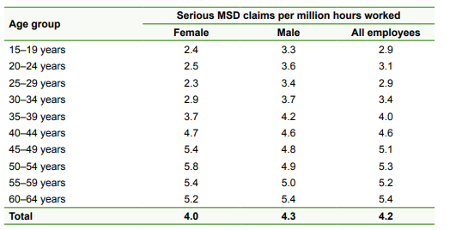
Table 1 | Frequency rates of serious MSD claims by age group and sex, 2009–10 to 2013–14 combined

Compliance and Enforcement Priorities
WorkSafe will focus its compliance and enforcement activities on:
- PCBUs with workers at greater risk of suffering from an MSD, such as those who:
  - employ labourers,
  - operate in the construction industry,
  - operate in the healthcare and social assistance industry, with a focus on PCBUs in residential care services and social assistance services, and
  - have a high percentage of older workers.

EVALUATION
WorkSafe ACT is committed to evaluating and reporting on its activities to support its strategic initiatives. This will be achieved through yearly review of implementation and a final evaluation report for the life of the Strategy.
The progress of the Strategy will be reported in WorkSafe ACT’s Annual Reports published on the website: https://www.worksafe.act.gov.au/

Safe Work Australia (SWA), Work-related Musculoskeletal Disorders in Australia 2019, p. 11.
Safe Work Australia (SWA), Work-related Musculoskeletal Disorders in Australia 2019, pp. 14-15.
Safe Work Australia (SWA), Work-related Musculoskeletal Disorders in Australia 2019, p. 8.
Safe Work Australia, Key Work Health and Safety Statistics, Australia 2021. A serious workers compensation claim is an accepted claim resulting in a total absence from work of one working week or more. Safe Work Australia notes that workers’ compensation data only gives a limited picture of work-related injuries and disease because workers’ compensation schemes do not generally cover self-employed workers. See Safe Work Australia (SWA), Explanatory Notes: National Data Set for Compensation-Based Statistics for Safe Work Australia 2020, p. 1.
Safe Work Australia (SWA), Statistics on Work-Related Musculoskeletal Disorders 2016, p. 5.
Safe Work Australia (SWA), Work-related Musculoskeletal Disorders in Australia 2019, pp. 15-16. The frequency rate of serious MSD claims between 2011-12 and 2015-16 was 3.8. See p. 48.
Safe Work Australia (SWA), Work-related Musculoskeletal Disorders in Australia 2019, p. 48.
For details on the ANZSCO classifications used here see the Australian Bureau of Statistics (ABS), ANZSCO - Australian and New Zealand Standard Classification of Occupations, 2021. ANZCO divides occupations into 8 major groups and 43 sub-major groups.
Safe Work Australia (SWA), Statistics on Work-Related Musculoskeletal Disorders 2016, 7-8.
ACT workers’ compensation data is provided to WorkSafe ACT by CMTTED’s Workers’ Safety and Industrial Relations Division.
For relevant discussion see Safe Work Australia (SWA), Work-related Musculoskeletal Disorders in Australia 2019, pp. 6 & 25-32.
Australian Bureau of Statistics (ABS), 2016 Census QuickStats: Australian Capital Territory.
The occupation sub-group ‘other labourers’ includes freight handlers and shelf fillers and miscellaneous labourers (a category which includes, among others, recycling and rubbish collectors, caretakers and handypersons.) See Australian Bureau of Statistics (ABS), ANZSCO - Australian and New Zealand Standard Classification of Occupations, 2021.
Safe Work Australia (SWA), Statistics on Work-Related Musculoskeletal Disorders 2016, p. 10. The statistics in this report are for the period 2009-10 to 2013-14. More recent frequency rate figures are not available. More recent figures for the total number of MSD claims by industry are available. The industries with the greatest number of MSD claims nationally are (in order) healthcare and social assistance, manufacturing, construction, and retail trade. Work-related Musculoskeletal Disorders in Australia 2019, 51-52. (These figures are from the 2015-16 FY).
Frequency rates, measured by the number of serious workers’ compensation claims per million hours worked, provide a more accurate measure of risk than the number of accepted serious claims by industry, given differences in the numbers of workers across different industries.
Industry employment figures are taken from the Australian Bureau of Statistics (ABS), Employed Persons by State, Territory and Industry Division of Main Job (ANZSIC) January 2022.
Safe Work Australia (SWA), Statistics on Work-Related Musculoskeletal Disorders 2016, p. 7.

